- 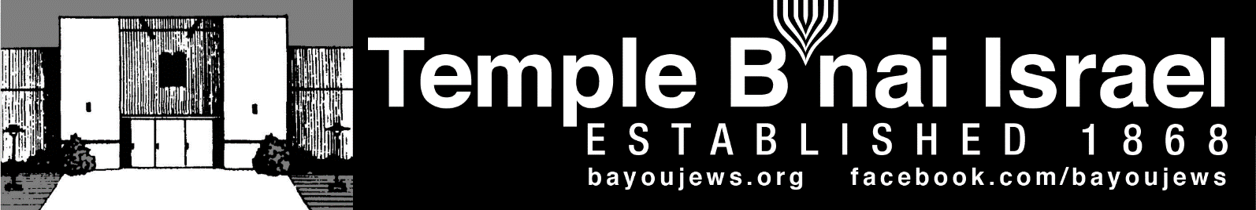

November 2022
Heshvan 7, 5783 – Kislev 6, 5783
______________________________________________________________________________
______________________________________________________________________________

RABBI JUDY’S MESSAGE
Hopefully by the time I see you in early November, it will feel a little more like Fall outside. The High Holy Days this year were beautiful. I am grateful for everyone who helped with the services – Nancy Carey (our soloist); Rick Seiler (our accompanist); Charles DeGiulian who played Kol Nidre so hauntingly on the violin and to all of our readers, Torah holders and helpers and those who worked behind the scenes to make the Holy Days run smoothly. It was good to be back and see many faces we had not seen in a few years.
Someone knew what they were doing because after all the holidays – Rosh Hashanah, Yom Kippur, Sukkot and Simchat Torah, we have a little break until Chanukah. We have time to catch our breath and try to implement some of those things we were going to do better in this New Year. I hope you have had some time to re-group and re-charge. We hope to see you at services as you reconnect with your Jewish community. We need to be there for one another especially as our numbers decrease. We are small, but we hold a mighty presence in the community of Northeastern Louisiana and we have a lot to be proud of as a congregation.
I will be with you on November 4 for Friday Shabbat services. And, I am excited that on Saturday, November 5, we will begin the day with a Bagel Bar followed by Torah Study at 9 am. I hope you will join us for a little “Knosh and Knowldege”. Our Torah study will be an analysis of one of our most essential prayers – the Shema found in Deuteronomy Chapter 6. At 10:15 am, I will welcome our families to join us for Shabbat Mishpocha (Family Shabbat).
If you need to schedule any time to speak with me, please let me know in advance so I can make sure to set aside some time. I hope to see many of you at Temple in about a week. Rabbi Judy
~~~~~~~~~~~~~~~~~~~~~~~~~~~~~~~~~~~~~~~~~~~~~~~~~~~~~~~~~~~~

SERVICE SCHEDULE

November 4th Rabbi Judy
November 11th Mike Rhymes
November 18th Alan Barth
November 25th Allison Dalton

Services will be held in person at the Temple, as well as live streamed through our website, www.bayoujews.org, unless otherwise noted.

Lay leaders are subject to change.

~~~~~~~~~~~~~~~~~~~~~~~~~~~~~~~~~~~~~~~~~~~~~~~~~~~~~~~~~~~~~

GRANT RECEIVED FROM NORTH LOUISIANA JEWISH FEDERATION
Our Congregation recently received a grant from the North Louisiana Jewish Federation (located in Shreveport) to provide some activities at our Temple for Jewish students attending ULM and LA Tech. We have identified a few students at ULM attending VCom and the undergraduate school. If you are aware of any Jewish students at ULM or LA Tech, please let Gay Nell or Shirley know. We are hoping to host a Shabbat dinner at Temple for them and have them as our guests at our Chanukah event and our Passover Seder in the spring. Many thanks to the Federation for their support.
~~~~~~~~~~~~~~~~~~~~~~~~~~~~~~~~~~~~~~~~~~~~~~~~~~~~~~~~~~~~~
CONGRATULATIONS

HAPPY BIRTHDAY

Don Marx – November 8th Jackson Jefferson – November 11th (12 yrs.)
Mel Cohen – November 11th Alan Barth – November 21st
Kelli Goza – November 22nd Christie Hakim – November 24th
Diane Rosenberg – November 28th Michael Masur – November 28th
~~~~~~~~~~~~~~~~~~~~~~~~~~~~~~~~~~~~~~~~~~~~~~~~~~~~~~~~~~~~~
~~~~~~~~~~~~~~~~~~~~~~~~~~~~~~~~~~~~~~~~~~~~~~~~~~~~~~~~~~~~~

PRESIDENT’S MESSAGE

Our High Holy Day services were beautiful and meaningful. The music provided by Nancy Carey, Rick Seiler, and Charles DiGiulian was wonderful. I hope they will all be able to join us again next year. Thank you to Mike Rhymes for providing the movies on Yom Kippur afternoon and the Sisterhood for the delicious Break Fast.

Rabbi Caroline Sim visiting from the ISJL had a wonderful Shabbat service, which included a short Sukkot service on the patio and a potluck dinner. Everyone that attended enjoyed her services and visiting with her at the potluck dinner. Thank you to everyone who contributed to the potluck and to Alan Barth for providing our “Sukkah”.

Saturday was full of activities with Rabbi Sim. She had Sukkot activities under the Sukkah and then everyone made edible Sukkahs. The Torah study was very meaningful and the members enjoyed the interaction. In the late afternoon, Rabbi Sim had a Simchat Torah service. She used her education training to be a scribe to point out the meaning of various parts of the Torah and its ornamentations. We are fortunate to have her in Monroe.

Rabbi Judy will be back on November 4 – 5. On Saturday, November 5th, we will have a bagel bar starting at 8:30 am, which will give you time to visit with the Rabbi before Torah Study, which will begin at 9 am. This will be followed by Shabbat Mishposha at 10:15 am.

Sunday, November 13th at 3 pm will bring the return of Movie Matinee hosted by Mike Rhymes. He hasn’t selected the movie yet, but I am sure that any movie Mike selects will be great.

Shirley will be on vacation the month of November. She will be going to Turkey to visit her in-laws. The office will be closed, but business will still be conducted, including Friday Shabbat services. The phones will be routed to Deb Roa.

Gay Nell Barth, President

~~~~~~~~~~~~~~~~~~~~~~~~~~~~~~~~~~~~~~~~~~~~~~~~~~~~~~~~~~~~~
~~~~~~~~~~~~~~~~~~~~~~~~~~~~~~~~~~~~~~~~~~~~~~~~~~~~~~~~~~~~~

RITUAL AND WORSHIP

Yom Kippur provided some beautiful music and meaningful sermons. Thank you to Rabbi Judy for the great sermons and to Nancy Carey, Rick Seiler and Charles DiGiulian for the music. I hope they will all be able to return for the High Holy Days next year.

I hope you enjoyed our short movies during the break between services on Yom Kippur. I want to thank everyone that participated with the services. Having members participate makes the Holy Days very special. And thank you to the Sisterhood for providing Break Fast.

Thank you to Rabbi Caroline Sim from the ISJL who was here to celebrate Sukkot and Simchat Torah. It is wonderful that we are able to have a Rabbi from the ISJL come to Monroe. All of the activities she planned for her visit were well received. Members were grateful for the time to visit with her during the potluck dinner. The kids had a great time with the Sukkot activities, which included looking at pictures to identify which were proper Sukkahs and why or why not.

We had some special guests for a couple of weeks. David and Catherine were visiting from Georgia (the country). David is originally from France and Catherine is from the Winsboro area. David treated us to his homemade challah each week.

I am pleased to bring back Movie Matinee on Sunday, November 13th at 3 pm. Refreshments will be available.

Mike Rhymes, Chair
~~~~~~~~~~~~~~~~~~~~~~~~~~~~~~~~~~~~~~~~~~~~~~~~~~~~~~~~~~~~~
DONATIONS

In Memory of Lynn Cohen

Archives Fund

Charles Masur Family

General Donation
Curtis Garth
~~~~~~~~~~~~~~~~~~~~~~~~~~~~~~~~~~~~~~~~~~~~~~~~~~~~~~~~~~~~~
~~~~~~~~~~~~~~~~~~~~~~~~~~~~~~~~~~~~~~~~~~~~~~~~~~~~~~~~~~~~~

YAHRZEIT

NOVEMBER 4TH

Joe E. Marx, Sr. Morris Lande
Robert Schendle Hanna Seligman 3-5

NOVEMBER 11TH

Rhoda Dubin Bessie Kaplan
Ernest M. Strauss Jules Dante
May Doernberg Abie Marx
Rabbi F. K. Hirsch Margarethe Gerson

NOVEMBER 18TH

Rose Lemle Masur Louis Krauss
Mildred May Harry Rabinovitch
Anna Snyder Dorothy King 5-11
Claire Leibowitz 5-2 Helen Seligman
Rebecca Kahn Dorothy Mintz 4-8
Irwin Kaufman
NOVEMBER 25TH

Johanna Chernow Nancy Dreyfus
Madeline Hirsch 2-21 Rosaline Liebreich 1-22
Estelle Rubin Simon Shlenker, Sr. 1-10
Abraham Tumaroff Leopold Baer
David Guter Mathilde Schochet
Sigmund Masur Sol Cahn 6-11
Gertrude Snyder 1-24 Yetta Dorn
Jessie G. Weil
NOVEMBER 30TH

Nathalie Haas HIrsch Ben Stern
Eva Felsenthal Heller

The numbers following a name are the location of their plaque on the Memorial Board in the Foyer. The first number represents the column. The second number represents the position in the column.
~~~~~~~~~~~~~~~~~~~~~~~~~~~~~~~~~~~~~~~~~~~~~~~~~~~~~~~~~~~~

~~~~~~~~~~~~~~~~~~~~~~~~~~~~~~~~~~~~~~~~~~~~~~~~~~~~~~~~~~~~~

SUNDAY SCHOOL

The children are enjoying their Sunday School classes and look forward to them every week.

Rabbi Caroline Sim was in Monroe for Sukkot services. She had a short Shabbat service and had some fun activities for the children. They went out on the patio, where we had a “sukkah” set up and discussed what would make a proper sukkah. She had several pictures for them to identify if the sukkah was “proper” and why. There were some lively discussions. Then they came in and built their own edible sukkahs. More pictures on the back page.

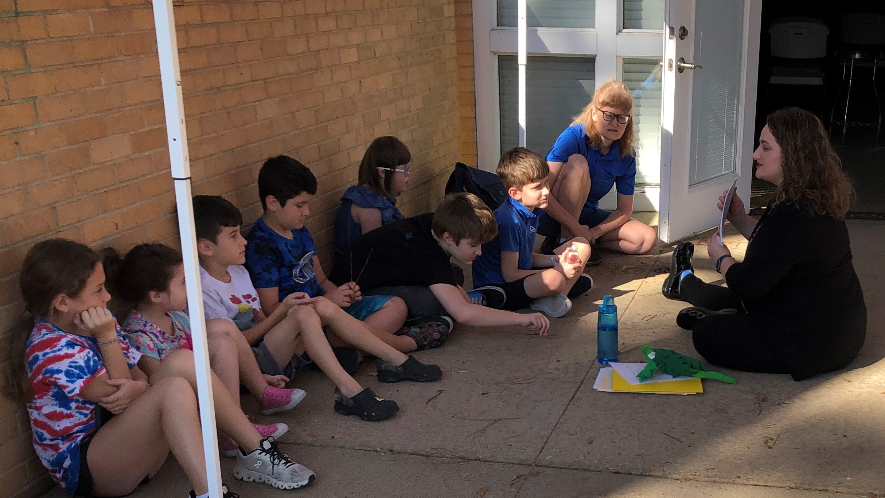
Identifying Sukkahs - Brylee Laudenheimer, Shai Hakim, Daniel Hakim, Joseph Hakim, Jonathan Allen, Rebecca Allen, Samuel Allen, Jennifer Allen, Rabbi Sim

Rabbi Judy will be in Monroe for Shabbat Mishpocha on November 5th at 10:15 am. Note the change in time. We will have Sunday School on November 13th, 20th, and 27th at the usual time.
~~~~~~~~~~~~~~~~~~~~~~~~~~~~~~~~~~~~~~~~~~~~~~~~~~~~~~~~~~~~~
Chanukah

Mark your calendars now. We will have out Chanukah party on the first night of Chanukah, Sunday, December 18th at 5 pm. Rabbi Judy will be here to celebrate with us.

If you know any Jewish university students that will be in the Monroe area on the 18th, please Shirley or Rabbi Judy know as soon as possible. We have scholarship money that would pay their costs.
~~~~~~~~~~~~~~~~~~~~~~~~~~~~~~~~~~~~~~~~~~~~~~~~~~~~~~~~~~~~~
\
~~~~~~~~~~~~~~~~~~~~~~~~~~~~~~~~~~~~~~~~~~~~~~~~~~~~~~~~~~~~~
ARCHIVES/MUSUEM

The month of October brought many visitors to worship and/or tour our museum. St. Paul’s confirmation class toured the museum and then attended services. I want to thank Deb Roa for conducting the tour and to Mike Rhymes, assisted by Don Smith for leading the service.

A couple from Tbilisi, Georgia was visiting in this area and attended services while they were here. He grew up in Paris, France and she grew up in the Monroe area. They took a quick tour of the museum. He wanted to practice his challah baking skills and brought challahs for two of our services.

Rabbi Caroline Sim from the ISJL spent a weekend with us and led several educational activities. We found out that no matter your age, there is always knowledge to acquire. Rabbi Sim is studying to be a scribe and explained the meaning of the various ornaments on the Torah. The finials on top of our Torahs represents pomegranates; the breast plates represent the breast plates the High Priests wore; each of the breastplates on our Torahs have a small Torah located behind a miniature ark covered by the ten commandments; the Hebrew written on the bottom of the breastplate tells the Rabbi which one to use for Shabbat and which to use for holidays. She also explained various aspects of writing a Torah, such as when you have made an error, what circumstances require the entire panel to be replaced and when the error can be corrected by eraser. She also pointed out there are no capital letters or punctuation on the Torah.

While passing through Monroe on their way to a Federation meeting in Dallas, Mary and Dr. Hal Lewis found the Precious Legacy Museum in one of the Visitor Bureau’s booklets. They contacted us and asked if they could tour the museum on Saturday. I was able to accommodate that request and suggested they may want to view the two short video tours on our website before they came to the Temple. Dr. Lewis has a Doctorate in Jewish Studies and teaches leadership techniques. Dr. & Mrs. Lewis were impressed with our sanctuary and the videos on the website.

The Blumenthal family has donated materials for our museum displays. Their donation is greatly appreciated.

Everyone have a wonderful Thanksgiving!

Sandra Blate, Administrator
~~~~~~~~~~~~~~~~~~~~~~~~~~~~~~~~~~~~~~~~~~~~~~~~~~~~~~~~~~~~~
HOLDING THE TORAHS DURING KOL NIDRE
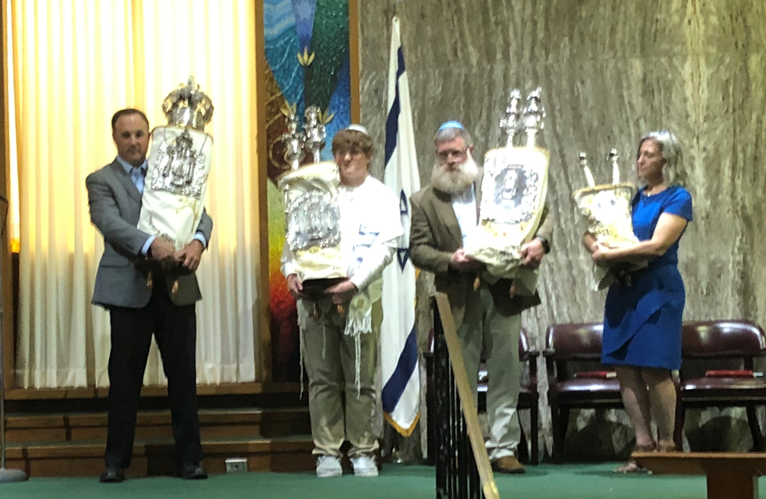
Jeff Laudenheimer, Jack Johnson, Chris Colbert, Deb Roa

SHAKING THE LULAV
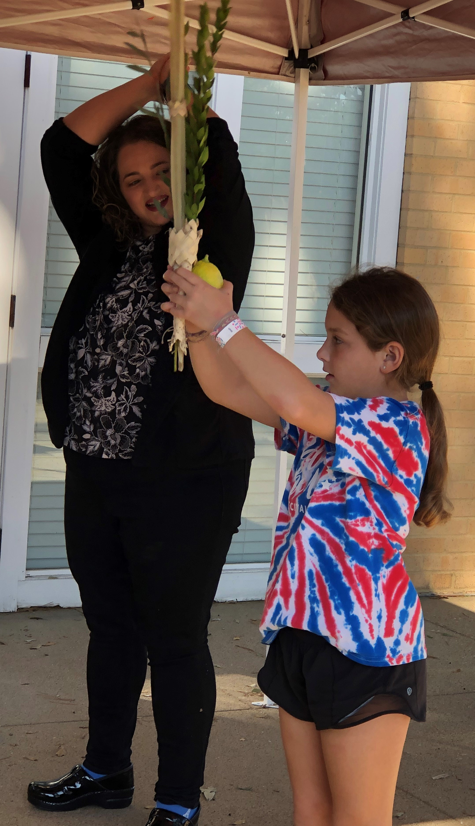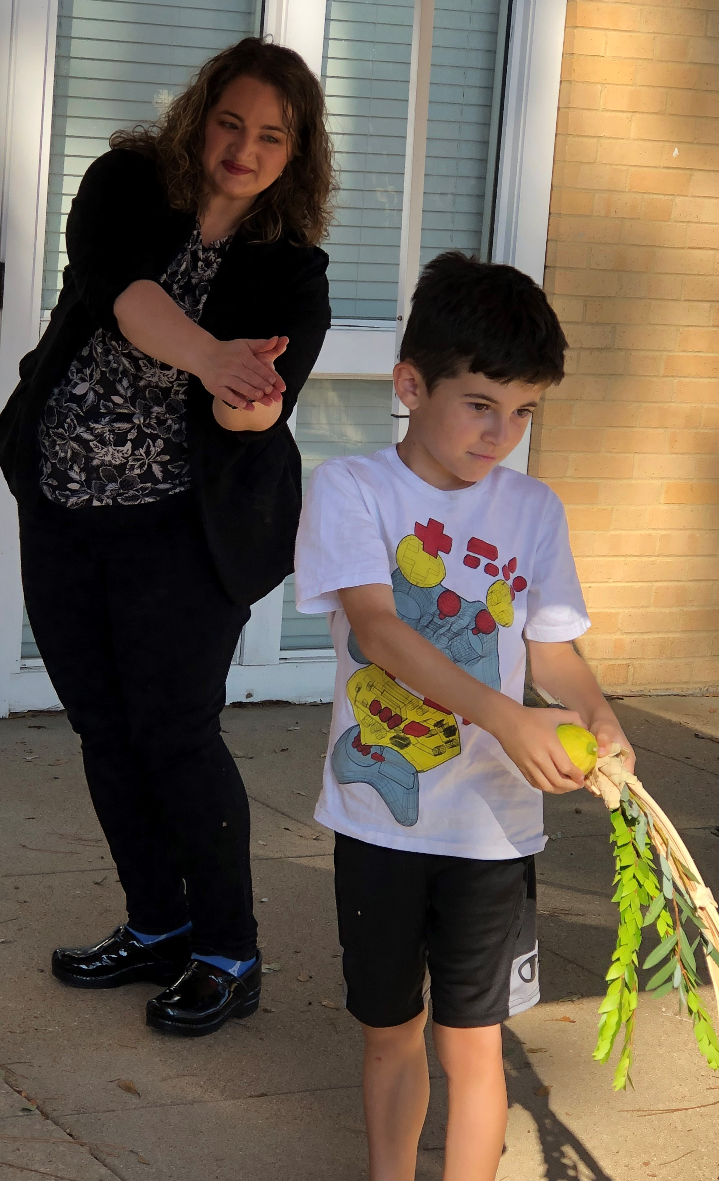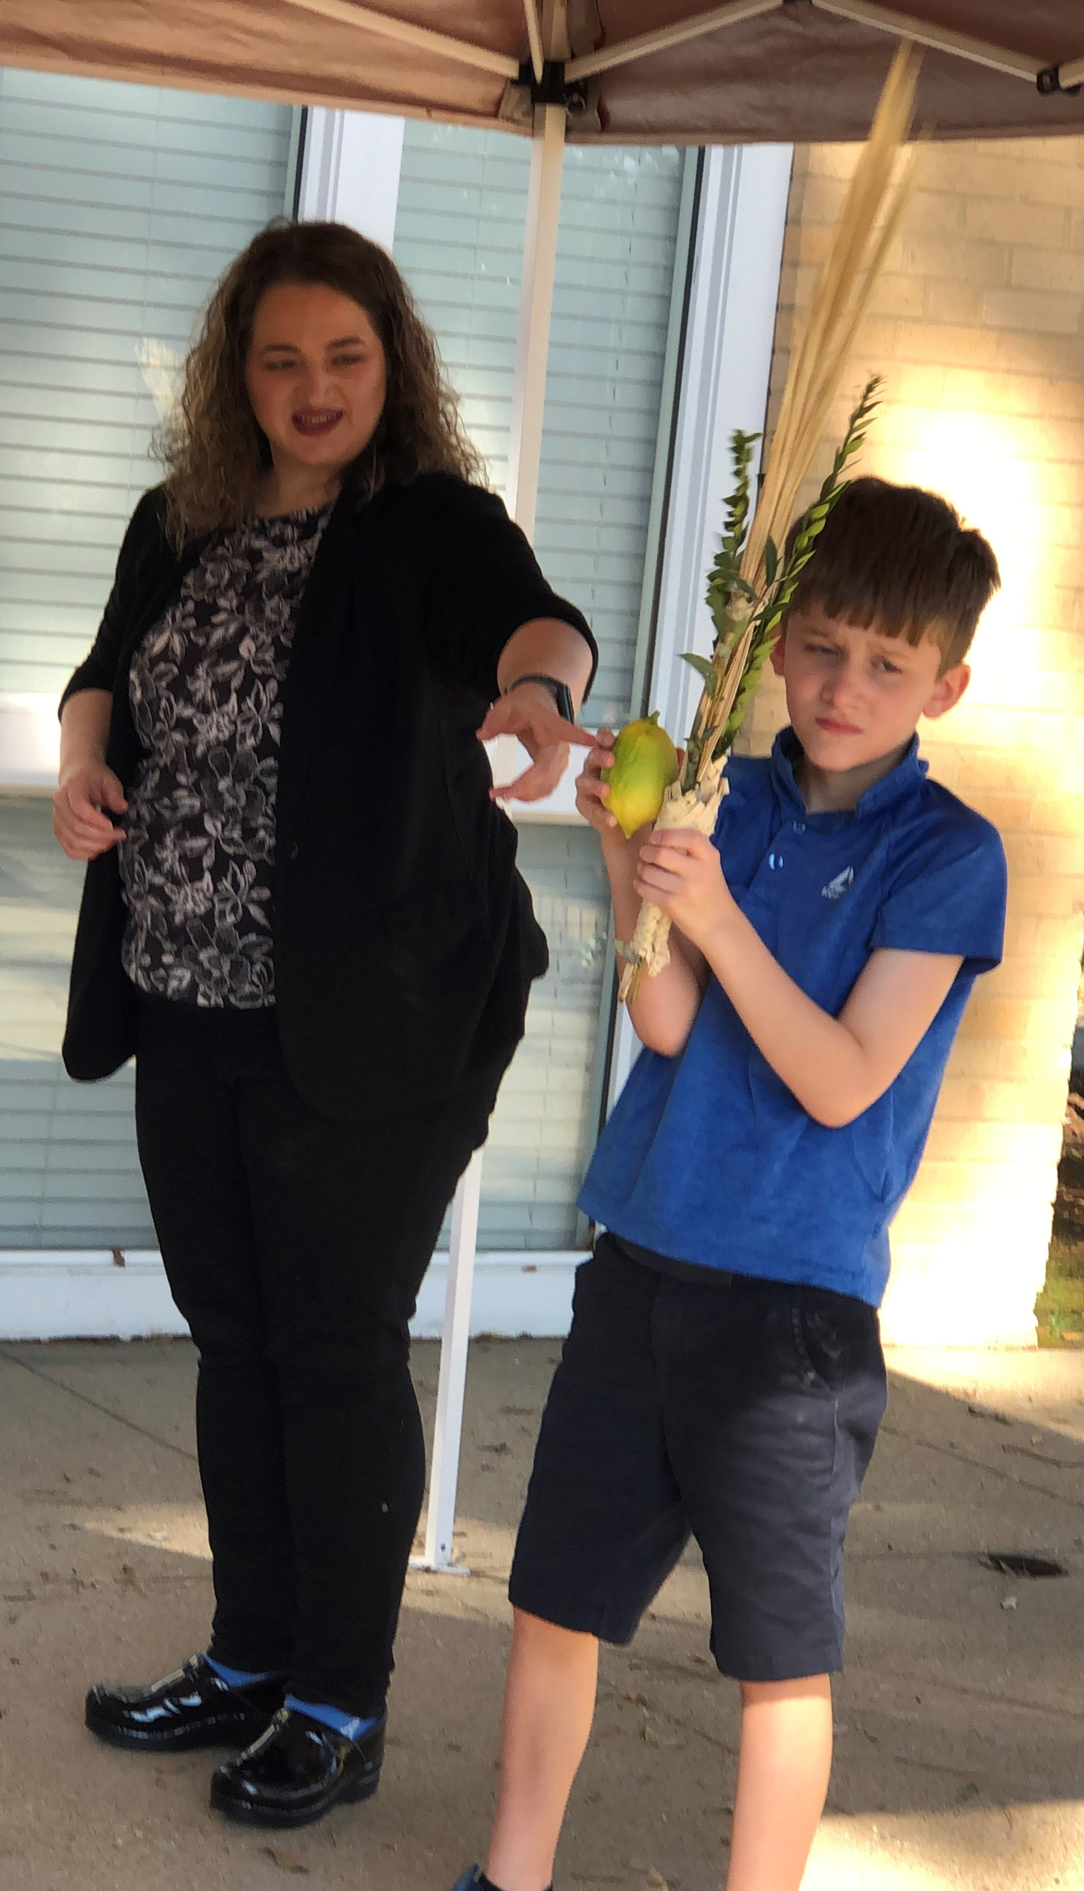
Rabbi & Brylee Laudenheimer Rabbi & Daniel Hakim Rabbi & Samuel Hakim

EDIBLE SUKKAHS
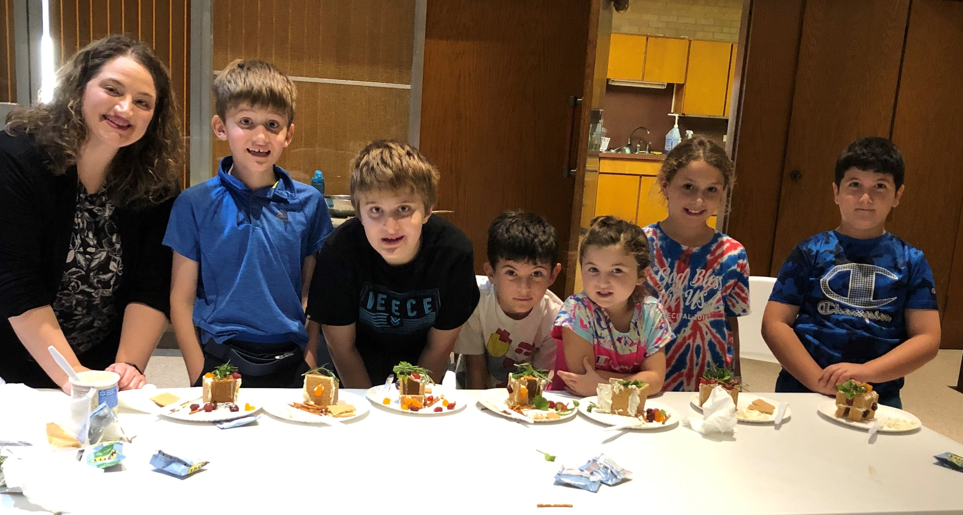
Rabbi Sim, Samuel Allen, Jonathan Allen, Daniel Hakim, Shai Hakim, Brylee Laudenheimer, Joseph Hakim

