- 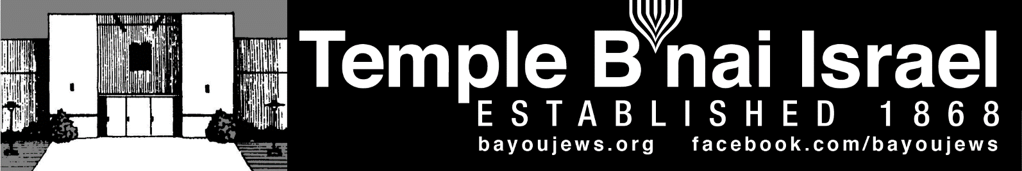

August 2022
Av 4, 5782 – Elul 4, 5782
______________________________________________________________________________
______________________________________________________________________________

RABBI JUDY’S MESSAGE
Bob and I have just returned from an incredible adventure visiting five countries (Italy, Greece, Albania, Montenegro and Croatia) and over sixteen cities. We visited the Great Synagogue in Rome and smaller synagogues with smaller Jewish communities or former Jewish communities in Albania, Corfu, Dubrovnik, Split and Zagreb. There was evidence of Jews in Split, Croatia as far back as the 4th century. It was not a vacation, but an incredible adventure where we saw so much beauty and walked between 10,000 and 20,000 steps a day!
It is good to be back home and I look forward to seeing you the weekend of August 19-20. This will a special weekend for our congregation. On Friday night, August 19, we will welcome five new Jews into our midst. Ryan-Elise Coen, Jarmarus Jefferson, Sable Jefferson, Annabelle Navarro, and Don Smith have been studying with me for the past year, and having met all the requirements for conversion, they are now ready to become members of our Jewish faith. I hope you will join us at Temple at 6 pm as we witness their sacred conversion and celebrate with them.
We will have Shabbat Mishpochah on Saturday at 9:30 am in the sanctuary and Torah Study in the library at 11 am.
If you need to schedule a visit with me, please contact me in advance. I will be coming in on Thursday, August 18 so I will have a little more time to spend.
Looking ahead, our congregation will celebrate another special occasion on Friday evening, September 2 and Saturday morning, September 3 as Jack Johnson (son of Allison Dalton) is called to the Torah as a Bar Mitzvah. It has been thirteen years since our congregation last celebrated a B’Mitzvah so this will truly be an event to celebrate in the life of our congregation. Jack has been studying diligently with both Rabbi Jana and me for the past year in preparation for this lifecycle event. We hope you will join us to celebrate with his family as we welcome Jack to take his place amongst our Jewish people.
Rabbi Judy
~~~~~~~~~~~~~~~~~~~~~~~~~~~~~~~~~~~~~~~~~~~~~~~~~~~~~~~~~~~~~
SERVICE SCHEDULE

August 5th Mike Rhymes
August 12th Deb Roa
August 19th Rabbi Judy
August 26th Alan Barth

Services will be held in person at the Temple, as well as live streamed through our website, www.bayoujews.org, unless otherwise noted.

Lay leaders are subject to change.

~~~~~~~~~~~~~~~~~~~~~~~~~~~~~~~~~~~~~~~~~~~~~~~~~~~~~~~~~~~~~
PRESIDENT’S MESSAGE

We appreciate everyone’s donations of can goods for local homeless veterans and box fans for the Ouachita Senior Citizen Center. What a great mitzvah for our local community.

I hope you take the opportunity to attend the Zoom concert Lapidus & Myles on August 11 at 7 pm. Contact the office for the Zoom link. If you do not have internet access and would like to attend the concert, please contact the office and Shirley will arrange to stream it at the office.

We are looking forward to welcoming the new conversion class into our faith. Please try to come to the celebration on August 19 and meet our converts. Don’t forget to introduce yourself to them.

We are excited to have Jack Johnson being called to the Torah as a Bar Mitzvah on September 3rd at 10:30 am. If you can’t make it to the Bar Mitzvah, please come to the oneg on September 2nd to meet and congratulate Jack.

We are beginning preparations for the High Holy Days. If you have any input on how to make the HHDs more meaningful, please contact me, Rabbi Judy, or Mike Rhymes.

Gay Nell Barth, President

~~~~~~~~~~~~~~~~~~~~~~~~~~~~~~~~~~~~~~~~~~~~~~~~~~~~~~~~~~~~~
~~~~~~~~~~~~~~~~~~~~~~~~~~~~~~~~~~~~~~~~~~~~~~~~~~~~~~~~~~~~~

YAHRZEIT

AUGUST 5TH

Melvin Greenblatt Ruth Zipkes
Ben Glazer 1-1 Henry Gerson Marks
Harry S. Roby Arthur Brueck 5-18
Nathan J. Laudenheimer 5-12

AUGUST 12TH

Ernest Blumenthal Moses Kaplan
Leo Oppenheimer

AUGUST 19TH

Linda Leibowitz 5-3 Celia Cohen Flemin
Arthur Marcus Mollie Froug
Augusta Cahn 6-5 Elliot Marcus

AUGUST 26TH

Irving Leeibowitz 5-1 Max Roby
Hilda Bodan Bertha Marx

AUGUST 31ST

Jonathan Brian Cohen 4-17 Abe Temerson

The numbers following a name are the location of their plaque on the Memorial Board in the Foyer. The first number represents the column. The second number represents the position in the column.
~~~~~~~~~~~~~~~~~~~~~~~~~~~~~~~~~~~~~~~~~~~~~~~~~~~~~~~~~~~~~

DONATIONS

In Memory of Rita Blumenthal

Archives Fund
Richard & Janet Shackelford

~~~~~~~~~~~~~~~~~~~~~~~~~~~~~~~~~~~~~~~~~~~~~~~~~~~~~~~~~~~~~
~~~~~~~~~~~~~~~~~~~~~~~~~~~~~~~~~~~~~~~~~~~~~~~~~~~~~~~~~~~~~

RITUAL AND WORSHIP

I would like to thank Sandra Blate and Deb Roa for leading services and Allison Dalton for leading our responsive readings in July.

We have been the offered the opportunity to partner with the ISJL to provide a free live concert on Zoom. Lupidus and Myles will be performing on August 11, at 7 pm central time. If you would like to watch this concert from the comfort of your home, please contact the office for the Zoom link. If you don’t have internet access and would like to attend the concert, please contact the office and Shirley will arrange to stream it at the Temple.

We are starting our preparation for High Holy Days (September 25 and October 4). We will be contact you to participate in the service during the next couple of months. If you would like to volunteer to be part of the service, you don’t have to wait for us to contact you. Just contact me or Shirley.

Mike Rhymes, Chair

~~~~~~~~~~~~~~~~~~~~~~~~~~~~~~~~~~~~~~~~~~~~~~~~~~~~~~~~~~~~~

NEW CONVERSION CLASS STARTING SOON
Rabbi Judy will be starting a new conversion class in the next few months. The class will be taught online using the Zoom platform. We recently received a grant to help with the expenses of this class and text books and activity kits will be provided to those in the class free of charge thanks to the generosity of the National Center to Encourage Judaism. There are already a couple of people signed up to take this year long course of study. We will meet once a month on Zoom usually on a Sunday morning. If you or someone you know is interested in converting to Judaism, please have them contact the Temple or Rabbi Judy ASAP so we can include them in this class.

~~~~~~~~~~~~~~~~~~~~~~~~~~~~~~~~~~~~~~~~~~~~~~~~~~~~~~~~~~~~~

~~~~~~~~~~~~~~~~~~~~~~~~~~~~~~~~~~~~~~~~~~~~~~~~~~~~~~~~~~~~~

CONGRATULATIONS

HAPPY ANNIVERSARY

Alan & Gay Nell Barth August 5th 44 years
Don & Judy Marx August 8th 57 years
Jackie & Diane Rosenberg August 9th 39 years
Ron & Sandra Blate August 12th 60 years
Joseph & Sharon Hakim August 15th 41 years

HAPPY BIRTHDAY
Morris Mintz – August 1st Charles Masur – August 2nd
Samuel Allen – August 2nd (9 years) Chris Colbert – August 2nd
Joseph Hakim – August (10 years) Jack Johnson – August 6th (15 years) Jacob Willitt – August 6th S. J. Shlosman – August 7th
Jack Hakim – August 10th Don Laudenheimer – August 12th
Philip Roby – August 14th Penny Hakim – August 15th
Herman Rosenberg – August 26th Allison Dalton – August 27th

~~~~~~~~~~~~~~~~~~~~~~~~~~~~~~~~~~~~~~~~~~~~~~~~~~~~~~~~~~~~~
~~~~~~~~~~~~~~~~~~~~~~~~~~~~~~~~~~~~~~~~~~~~~~~~~~~~~~~~~~~~~

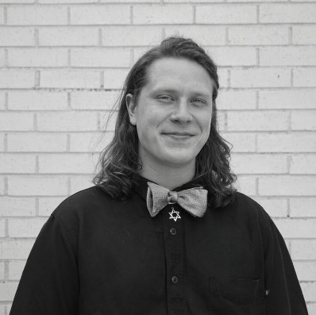
Ezra Scherrer, our B’al T’kiah (shofar blower) is now a Program Associate with the Institute of Southern Jewish Life (ISJL) in Jackson. Ezra will serve in this position until 2024 and, who knows, we might just see him on a visit. We are proud of you, Ezra!

~~~~~~~~~~~~~~~~~~~~~~~~~~~~~~~~~~~~~~~~~~~~~~~~~~~~~~~~~~~~~

ARCHIVES/MUSEUM NEWS
I participated in the Directors Passport Camp in July. I partnered with the Children’s Museum and made a presentation on Iran, Purim, and hamanstachen. The children had fun learning how to make a triangle out of a circle. The ladies who run the museum were fascinated and so excited watching the demonstration on making hamanstachen they made some themselves.

Also in July, I gave a guided tour of the Precious Legacy Museum and the Temple to a group of 18 retirees from Lee Joyner United Methodist Church. The feedback was very positive. Since May 81 people have toured our museum.

The Gourmet Cooking School Class which was postponed in July has been rescheduled for October. The exact date is still to be determined.

Some time ago I provided information on our 2ne temple building to the College of Charleston Jewish Studies for their virtual exhibit Synagogues of the South. The exhibit studies and describes the different types of architecture used by the Jewish communities in the early 20th century. The images of the synagogues are from postcards. Here is the link that will take you directly to our synagogue, but feel free to browse the entire exhibit.
https://synagoguesofthesouth.cofc.edu/synagogues/monroe-la-bnai-israel-bene-israel-1917/. Did you ever think our Precious Legacy Museum would get us national recognition!?!

Sandra Blate
~~~~~~~~~~~~~~~~~~~~~~~~~~~~~~~~~~~~~~~~~~~~~~~~~~~~~~~~~~~~~
~~~~~~~~~~~~~~~~~~~~~~~~~~~~~~~~~~~~~~~~~~~~~~~~~~~~~~~~~~~~~
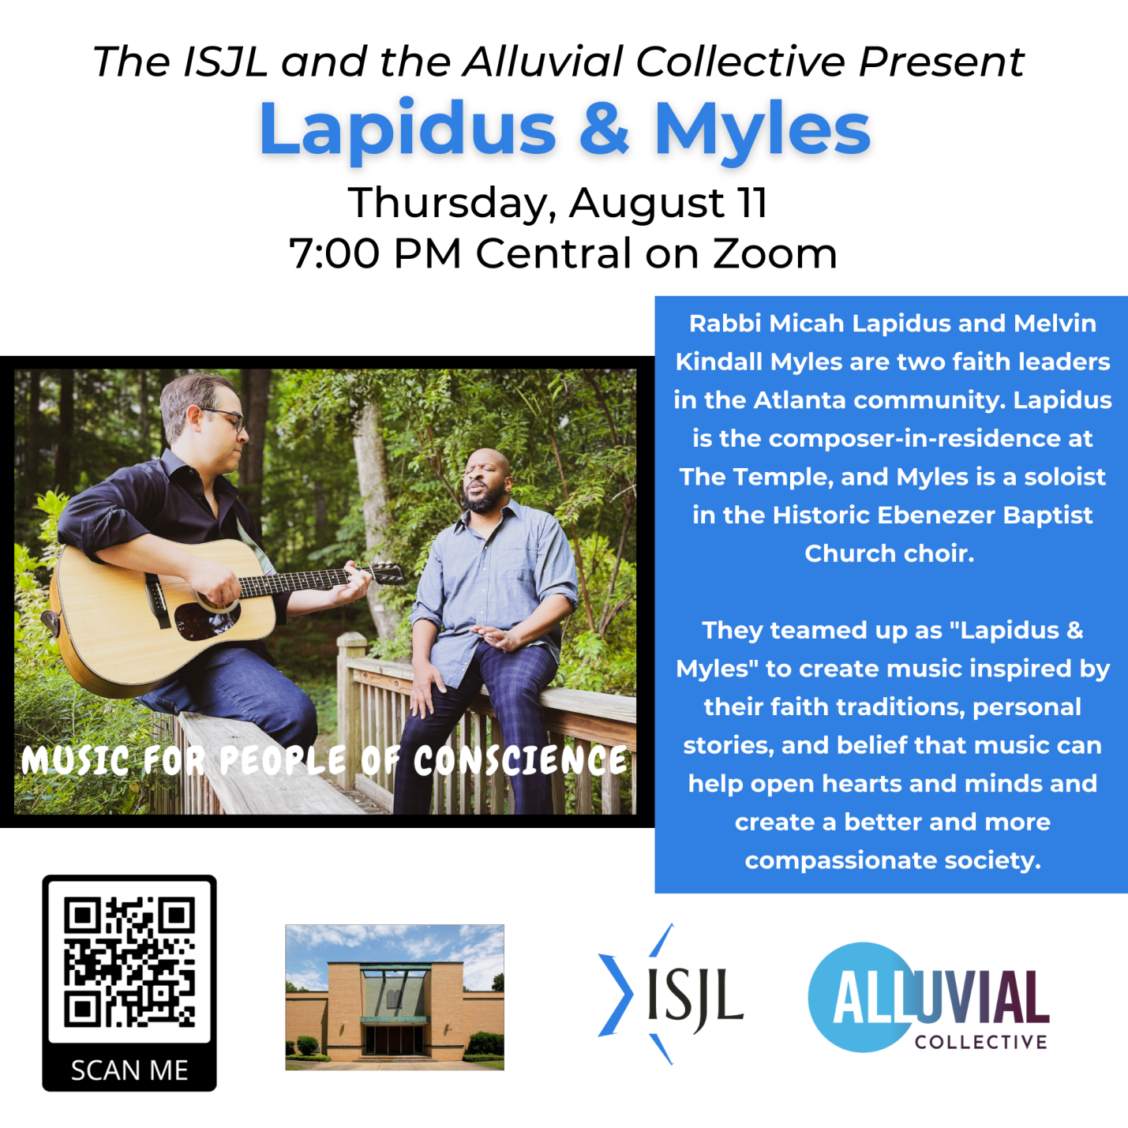

If you would like to watch this concert from the comfort of your home, please contact the office for the Zoom link. If you do not have internet access, contact Shirley and she will stream it from the Temple.

~~~~~~~~~~~~~~~~~~~~~~~~~~~~~~~~~~~~~~~~~~~~~~~~~~~~~~~~~~~~~

Dear Fellow Congregants,

In 1992, the Board of Trustees established the tradition of publishing a Book of Remembrance
to be distributed on Yom Kippur. With your help, this simple dignified means of honoring the
memory of our beloved departed will once again become part of our memorial service on
Yom Kippur. The book will be distributed at the Yizkor Service on the afternoon of Yom Kippur.

To have the names of your cherished departed included in the Book Of Remembrance,
please fill out this page and return to the Temple office no later than September 1, 2022.
It is also a tradition to honor the memories of our loved ones with a special Yizkor donation
to the Temple. Let the memories of our past help provide for our future.

L’shanah tovah!
Gay Nell Barth, President
_______________________________________________________________

Please include the names listed below in Temple B’nai Israel’s Book of Remembrance.

I have enclosed a Yizkor donation of_____$10_____$20_____$50_____$100____other.

Remembered By: ________________________________________________________

Names (please print)

________________________________ ___________________________________

________________________________ ___________________________________

________________________________ ___________________________________

________________________________ ___________________________________

________________________________ ___________________________________

________________________________ ___________________________________

