April 2020
Nissan 7, 5780 – Iyar 6, 5780
______________________________________________________________________________
______________________________________________________________________________

RABBI JUDY’S MESSAGE
Last month, we welcomed seven new Jewish people to our community. These men and women dedicated themselves to studying with me for the past year to learn all they could about being Jewish. However, I reminded them many times that this is just the beginning of their Jewish learning. The learning never stops….there is always more to learn and more ways to grow in faith and community. Many thanks to Shirley for all she did to help with the service and to Betsy Laudenheimer and the other Sisterhood members who baked for the oneg. It was a very special night.
Little did we know that this special Shabbat would be our last in the synagogue for many weeks. With Passover just a few weeks away, COVID-19 (the 11th plague) is upon us. Our state is being hit particularly hard. The Governor has ordered all of us to “shelter in place” meaning most of us have been staying in our homes – either working from home or not working at all – with no physical contact with those outside of our homes. This has been difficult for some and challenging for most. We have had to learn new ways of doing things. But, on the positive side, we have much more time to connect with family, clean our house, do things around the house that we have put off for years, indulge in a hobby or two.
For those of you who are able to get online, I am offering Shabbat services every Friday night at 6 pm CST on the Zoom platform. The link to join the service is https://zoom.us/j/3184428863 This link will remain the same for each service. On Friday, April 10 (the night of our planned community seder), I will be offering a virtual seder online beginning at 5 pm. (Use that same zoom link to join). The Haggadah will be posted on the screen for all to see and we will take turns reading just like at a real seder table. If you join the Seder, you may want to have the following items available to fully participate (or just participate virtually, if you wish): Shabbat candles to light, wine or grape juice to drink, matza, parsley, bitter herbs, charoset.
During a time of crisis, we depend on others to lead and inform us, but we must rely on ourselves to follow, to listen, and to self-soothe. In the past, the Psalmist addressed uncertain times with words that proved to be timeless and timely. Consider the following list of Psalms and their

Rabbi’s Message Continued

purpose. Use them for yourself and others now and in the future. I hope they will provide you with comfort.
When God seems far away: Psalm 139
When you feel discouraged: Psalm 40
When you are lonely or fearful: Psalm 23
When you forget your blessings: Psalm 103
When the world seems bigger than God: Psalm 90
When you leave home for work or long-distance travel: Psalm 121
When your prayers grow narrow or selfish: Psalm 67
When people fail or disappoint you: Psalm 27
When you have stumbled or transgressed: Psalm 51
When you feel that you are in danger: Psalm 91
When you feel sad or despairing: Psalm 34
PSALMS LINK
I hope all of you are staying healthy and safe. Please keep us informed and check on one another. We may not be able to congregate, hug or shake hands, but we can open our hearts to one another at this difficult and scary time. If you are in need of something, reach out to a neighbor or one of us at the Temple. If you need to talk to me, I am available to you and can be reached at 318 442-8863 or by email at judy@rabbijudymusic.com. I continue to keep everyone at B’nai Israel in my prayers and long for the day when we can once again see each other face to face and give each other a great big hug.
~~~~~~~~~~~~~~~~~~~~~~~~~~~~~~~~~~~~~~~~~~~~~~~~~~~~~~~~~~~~~

PASSOVER SEDER
Rabbi Judy will have a virtual Passover service on April 10th at 5 pm. If you need help accessing the service, a tutorial can be found on home page our website. www.bayoujews.org. Note this service starts earlier than our regular services.
~~~~~~~~~~~~~~~~~~~~~~~~~~~~~~~~~~~~~~~~~~~~~~~~~~~~~~~~~~~~~
~~~~~~~~~~~~~~~~~~~~~~~~~~~~~~~~~~~~~~~~~~~~~~~~~~~~~~~~~~~~~

MESSAGE FROM THE PRESIDENT

I appreciate everyone’s patience and understand as we Shelter in Place in accordance with Governor Edward’s order. The Temple is closed and Shabbat services at the Temple are cancelled until further notice. We are working from home to keep day to day operations going. Rabbi Judy will have Virtual (Online) Shabbat Services until the Governor’s order is rescinded. Information on how to connect to the services are on the attachment.

Please remember to follow the CDC’s recommendations on staying safe and curtail the spread on the COVID-19 virus. Wash your hands for at least 20 seconds frequently, use hand sanitizer when soap and water is not available, don’t touch your eyes, nose or mouth with unwashed hands, only go out in public places when necessary, and practice “safe distancing” – allow 6 feet between you and other people in public.

I will provide information on the situation as it affects Temple activities as the information is available. Be assured that the Board of Trustees is keeping your health and safety as priority when making decisions regarding the Temple.

Stay home and be safe.

Alan Barth, President

~~~~~~~~~~~~~~~~~~~~~~~~~~~~~~~~~~~~~~~~~~~~~~~~~~~~~~~~~~~~~

SERVICE SCHEDULE

April 3rd
April 10th PASSOVER
April 17th
April 24th

All Shabbat services, including the Passover service, will be Virtual Shabbat Services with Rabbi Judy.

~~~~~~~~~~~~~~~~~~~~~~~~~~~~~~~~~~~~~~~~~~~~~~~~~~~~~~~~~~~~~

~~~~~~~~~~~~~~~~~~~~~~~~~~~~~~~~~~~~~~~~~~~~~~~~~~~~~~~~~~~~~

RITUAL AND WORSHIP
Thank you to Kash Schriefer for leading services on March 6th. Your willingness to lead services is greatly appreciated.

I also want to thank Rabbi Judy for the beautiful service on March 13th publicly welcoming the 7 new converts to the Jewish religion. Congratulations and welcome to all the converts – Mark Albritton, Curtis Brown, Chris Colbert, Allison Dalton, Heather Dickinson, Ethan Scherrer, and Massie Willett.

Allison Dalton, Heather Dickinson and Chris Colbert have become members of our Temple and I want to welcome them to our Temple family. The other converts have expressed interest, but not yet applied for membership.

I appreciate Rabbi Judy having Virtual Shabbat Services while we are complying with the Governor’s Shelter in Place order. Please join her online. We will resume regular Shabbat services at the Temple when the Governor rescinds his Shelter In Place order and the Board of Trustees feels it is safe to do so.

Mike Rhymes, Chair

~~~~~~~~~~~~~~~~~~~~~~~~~~~~~~~~~~~~~~~~~~~~~~~~~~~~~~~~~~~~~

CONGRATULATIONS

HAPPY ANNIVERSARY
Don & Phyllis Marcus April 4th 66 years
Jimmie & Betsy Laudenheimer April 7th 30 years

HAPPY BIRTHDAY

Cynthia Kern – April 1st Melinda Mintz – April 4th
Leonard Baize – April 6th Daniel Hakim (6 yrs) – April 17th Mike Rhymes – April 18th Judy Marx – April 22nd
Pam Laudenheimer – April 23rd Jo Agbasi – April 27th
Christopher Dickinson – April 28th Nancy King – April 29th

~~~~~~~~~~~~~~~~~~~~~~~~~~~~~~~~~~~~~~~~~~~~~~~~~~~~~~~~~~~~~

~~~~~~~~~~~~~~~~~~~~~~~~~~~~~~~~~~~~~~~~~~~~~~~~~~~~~~~~~~~~~
YAHRZEIT

APRIL 3RD

Hattie Strauss Gertie Scherck Jones 3-18
Jack Masur Jake Carlie
David L. Davidson Bernard Freiberg

APRIL 10TH

Sophie W. Smith Selma Tolchinsky
Mary Ann (Mimi) Cahn 6-10 Sophie Rosenberg
Hannah W. Shlenker 1-9 Hans Kern 5-22
Judy LaSov Rosalie Fischel Rose
Frances LaSov Alan Sugar
Ann S. Cohn Nathan Kern

APRIL 17TH

Regina Scherck 3-12 Emma Sugar
Birdie Marx Jack Rubin
Clara S. Kaplan Jacob Benjamin Pickens
Cecil Mack Adler Henry Haas, Sr. 2-18
Louis Masur 1-2

APRIL 24TH

Leon Sugar 5-6 Molly Abrams 3-2
Beatrice Finkelor Milton J. Neumann
Maurice Glazer David Snyder

APRIL 30TH

Charles Flemin Fred Lowe
Rose Goldman Masur 1-6

~~~~~~~~~~~~~~~~~~~~~~~~~~~~~~~~~~~~~~~~~~~~~~~~~~~~~~~~~~~~

~~~~~~~~~~~~~~~~~~~~~~~~~~~~~~~~~~~~~~~~~~~~~~~~~~~~~~~~~~~~~
ARCHIVES/MUSEUM NEWS
Thank you to the congregation and the sisterhood for each donating $500.00 to the archives for continuing interviews of congregants. Additional funds are needed to complete this project and donations of any size are welcome. We will start the interviews as soon practical.

The Precious Legacy Archives/Museum is compiling a mailing/emailing list of people who grew up here and now live elsewhere to allow them to stay in connected to B’nai Israel. Please share your children’s or sibling’s contact information.

Sandra Blate

~~~~~~~~~~~~~~~~~~~~~~~~~~~~~~~~~~~~~~~~~~~~~~~~~~~~~~~~~~~~~
NORTH LOUISIANA JEWISH FEDERATION

The Shreveport showing of the film Unexpected Modernism has tentatively been rescheduled for June 25th. The North Louisiana Arts Council is will also sponsor a showing of the film at The Flying Tiger Brewery sometime this summer. Dates and times will be provided as they become available

Sandra Blate
North Louisiana Jewish Federation, Monroe Representative

~~~~~~~~~~~~~~~~~~~~~~~~~~~~~~~~~~~~~~~~~~~~~~~~~~~~~~~~~~~~~

SUNDAY SCHOOL – MARCH 8, 2020

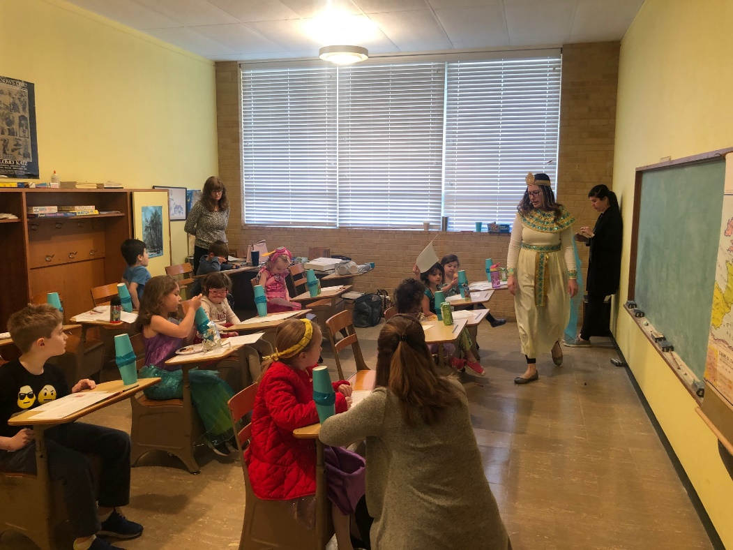

TOT SHABBAT – MAKING HAMANTASCHEN WITH RABBI JUDY

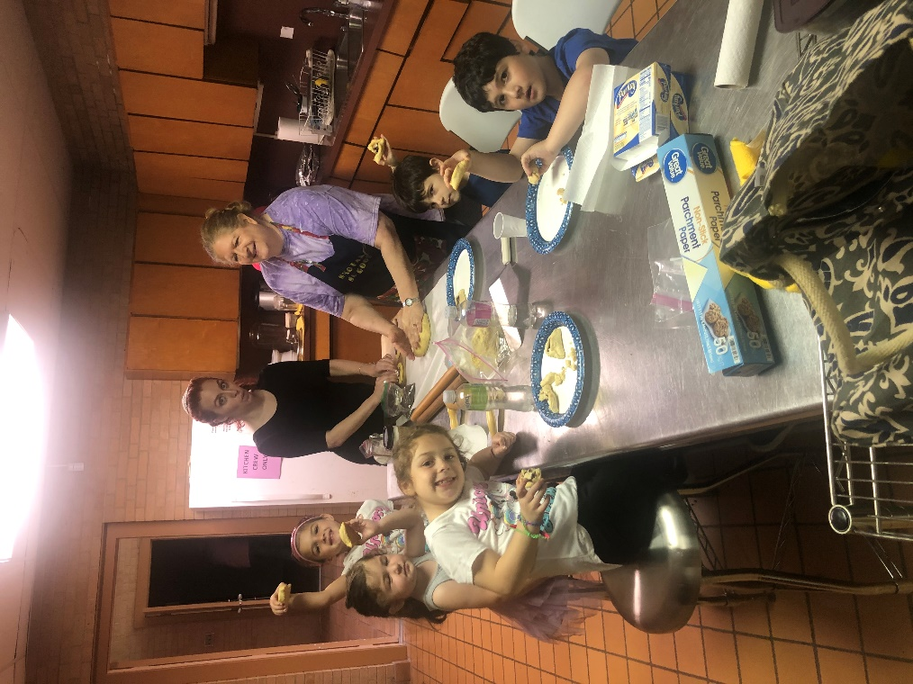
The conversion class – Public Welcoming Service
March 13, 2020

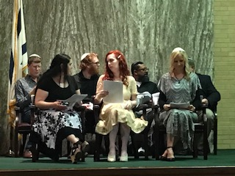

Ethan Scherrer, Heather Dickinson, Mark Albritton, Massie Willett, Curtis Brown, Allison Dalton, Chris Colbert

CONGRATULATIONS AND WELCOME!!

