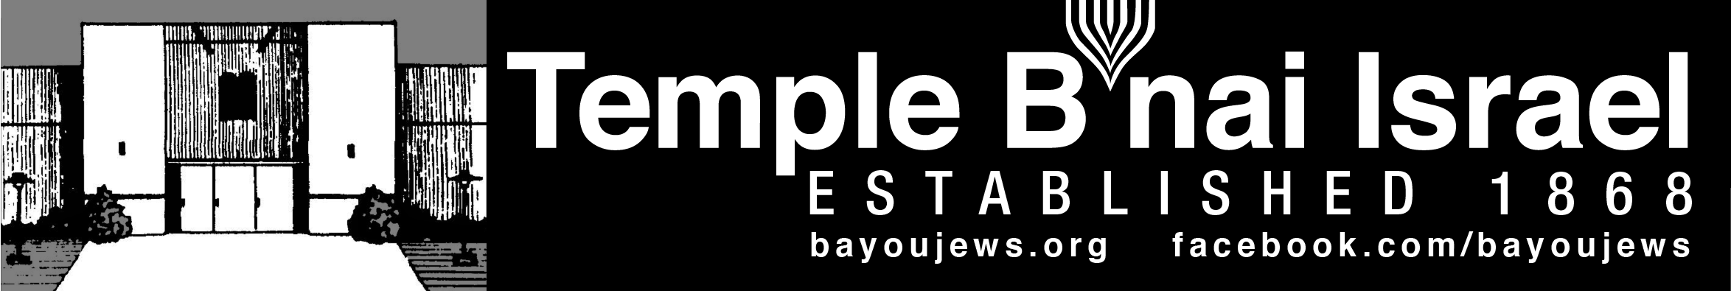
December 2018
Kislev 22, 5779 – Tevet 23, 5779
______________________________________________________________________________
______________________________________________________________________________

CHANUKAH CANDLE BLESSINGS
When we light the candles, we say blessings. Each night, we say the following two blessings:

- Ba-ruch A-tah Ado-nai E-lo-he-nu Me-lech ha-olam a-sher ki-de-sha-nu be-mitz-votav ve-tzi-va-nu le-had-lik ner shel Cha-nu-kah.

- Ba-ruch A-tah Ado-nai E-lo-he-nu Me-lech Ha-olam she-a-sa ni-sim la-avo-te-nu baya-mim ha-hem Baz-man ha-zeh.

On the first night only, we add this blessing:

- Ba-ruch A-tah Ado-nai E-lo-he-nu Me-lech Ha-olam she-heche-ya-nu ve-ki-yi-ma-nu ve-higi-ya-nu laz-man ha-zeh.

Translations:

- Blessed are You, Adonai our God, Sovereign of the universe, who has sanctified us with Your commandments, and commanded us to kindle the Chanukah light.

- Blessed are You, Adonai our God, Sovereign of the universe, who performed miracles for our ancestors in those days, at this time.

- Blessed are You, Adonai our God, Sovereign of the universe who has granted us life, sustained us, and enabled us to reach this season.

RABBI JUDY’S MESSAGE
Happy Chanukah!
Chanukah is early this year. I like that for many reasons. Mainly because it gives Chanukah its own space in the month of December. And, the two people in my family who celebrate birthdays in mid to late December can have real birthdays this year without interfering with Chanukah.
I love the holiday of Chanukah because of its family traditions and the light that it brings into our lives. Our family traditions include eating salmon patties and latkes – some with applesauce, some with sour cream. So, I usually spend a lot of time in the kitchen frying things. We also wrap lots of little presents for the children in the family and place them on the dining room table. Each night, everyone gets to pick a gift to open after we sing the blessings and light the candles. And, we have a tradition of allowing everyone to light their own personal menorah. Each night, we gaze at the candles and remember the holiness of the miracle they represent.
According to Maimonides (Rambam), these Chanukah lights are holy. They are lit to manifest and reveal the miracle. Permission is not granted to use them, instead, we are merely to look at them.
This year, when you light your menorah, take a few minutes to look at the candles and the flames. What are they trying to tell us? Looking at them begs us to slow down, relax and take notice.
When you look at the candles, you see three basic elements – flame, wick and wax. The Zohar teaches that the body is similar to the wick. The flame is the divine presence. And the wax joins the two together illuminating our good deeds and revealing how we are partners with God in repairing our world. The candle (ner in Hebrew) is a reflection of ourselves. Our physical being (wick) receives a soul from God (flame) and the wax or oil holds it all together. The Hebrew word nefesh means spirit or soul, This word is made up of three letters – nun, pei and shin and is an acronym for ner (candle), pesilah (wick) and shemen (oil). The candle is a reflection of our soul.
I like to think that each of us can be like a Chanukah candle shining our light into the darkness. The light from one candle can light many other candles and by shining our lights together, we bring more brightness into - what can sometimes be - a dark world.
I hope you will continue or create your own family Chanukah traditions to make your celebration of this joyous holiday memorable and meaningful.
Happy Chanukah!
Rabbi Judy

~~~~~~~~~~~~~~~~~~~~~~~~~~~~~~~~~~~~~~~~~~~~~~~~~~~~~~~~~~~~~

MESSAGE FROM THE PRESIDENT

It was nice to see such a large attendance at our memorial service for the victims of the horrific shooting in Pittsburgh. We were honored to have so many of the community religious leaders and general public joining us. A special thank you to Mike Rhymes, Bob Eisenstadt, and Rabbi Judy for putting together the beautiful service and to Rev. Welton Gaddy for his moving sermon. We have conveyed condolences and support from the community to the Tree of Life Synagogue, along with the very generous contributions that were made.

Congratulations to the Men’s Club on their successful Hot Dog sale.

This year’s Hanukkah party will be on December 7th, at 6 pm. We have invited some of the local religious leaders to join us that evening.

Happy Hanukkah!!

Alan Barth, President

~~~~~~~~~~~~~~~~~~~~~~~~~~~~~~~~~~~~~~~~~~~~~~~~~~~~~~~~~~~~~

SISTERHOOD CHANUKAH BRUNCH

Tuesday, December 4th at 11:30 a.m.
Betsy Laudenheimer’s Home
3508 Lake DeSiard Drive

*Please call or email Betsy for reservations by noon on Friday, November 30th .

Betsy Laudenheimer
Sisterhood President

~~~~~~~~~~~~~~~~~~~~~~~~~~~~~~~~~~~~~~~~~~~~~~~~~~~~~~~~~~~~~

~~~~~~~~~~~~~~~~~~~~~~~~~~~~~~~~~~~~~~~~~~~~~~~~~~~~~~~~~~~~

YAHRZEIT

DECEMBER 7TH

Bernard Levi 2-24 Nathan Shapiro
Martin Lerner 1-15 David Heller Masur 1-5 Annette Milligan Doris Stern Levinson
Hannah (Sis) Kahn Lowentritt Dave Marcovitz
Julia Marx Charles Snyder 2-2
Fredric King 5-9 Sampson Snyder 1-23

DECEMBER 14TH

Julia Heninger Esther Sandler
Sadie Ansel Bessie Barton
Joe Dante 4-1 Paul Fink
Jacob Seligman Joe Schendle

DECEMBER 21ST

Hylda Klotz 3-13 Josh Bodan
Eugene Cahn 6-9 Anna Rubin Raphael 1-20
Dorothy P. Lowentritt Laura Pickens
Tola Rosenberg 5-19 William I. Perlstein 2-22

DECEMBER 28TH

Sanford Halperin 5-16 Max Strauss
Arthur Mason Victor Cahn 6-4
Dorothy Gluck Otto Haas 4-9
Harriet Kern Manuel Slipakoff
Beatrice Masur

Yahrzeit Continued

DECEMBER 31ST

Morris Blumenthal Frances Kaplan
Samuel Klotz 2-23 Maurice Roby
Dora Israel Dr. Stanley Mintz
Fran Willing

The numbers following a name is the location of their plaque on the Memorial Board in the Foyer. The first number represents the column. The second number represents the position in the column. The lights on both sides of the plaque are light during the week of their Yahrzeit. If you would like to have your loved one remembered with a bronze plaque on the memorial board, order forms are available at the Temple.

~~~~~~~~~~~~~~~~~~~~~~~~~~~~~~~~~~~~~~~~~~~~~~~~~~~~~~~~~~~~~

SERVICE SCHEDULE

December 7th Rabbi Judy
December 14th TBA
December 21st TBA
December 28th TBA

Lay leaders are subject to change.

~~~~~~~~~~~~~~~~~~~~~~~~~~~~~~~~~~~~~~~~~~~~~~~~~~~~~~~~~~~~~

Introduction to Judaism

Rabbi Judy will be leading an Introduction to Judaism class on Saturday, January 26, 2019, from 1-4 pm. The class will cover what Jews believe, holidays and customs, Israel and more. There will be an “Ask the Rabbi” session at the end, with the opportunity to tour the museum and Synagogue. The class is free and open to everyone. Pre-registration is required. Please call the office for more information or to register. Flyers are available at the back of the sanctuary for you to share with your friends and family.

~~~~~~~~~~~~~~~~~~~~~~~~~~~~~~~~~~~~~~~~~~~~~~~~~~~~~~~~~~~~~
~~~~~~~~~~~~~~~~~~~~~~~~~~~~~~~~~~~~~~~~~~~~~~~~~~~~~~~~~~~~~

KALLAH UPDATE

We have met and discussed new and different activities for all ages this April. Please feel free to contact me if you would like to join us in designing the April Kallah . All are welcome and I hope you will pick up the registration forms at the Temple. You may also register online or call Shirley for details.

This year we are hoping and planning for better weather and a wider variety of activities for all. Looking forward to hearing from you and seeing you at the Kallah!!! Happy Hanukkah to All!

Here is the link to register on line:
www.123formbuilder.com/form-3083642/event-registration-form

Susan Marx
323-7521
~~~~~~~~~~~~~~~~~~~~~~~~~~~~~~~~~~~~~~~~~~~~~~~~~~~~~~~~~~~~~

MEN’S CLUB

We had a very successful Kosher-style Hot Dog Sale. Thank you to all that helped by purchasing and selling tickets. A special thank you to all that came out the day of the sale and helped us with the preparation and filling the orders.

The Men’s Club is selling memorial candles for $3. We have put the Hanukkah candles on sale 2 for $5. These can be found in the lobby and are available during office hours and on Friday evenings.

We will be providing the latkes for the Hanukkah party on December 7th. This year we will be preparing them on Thursday, December 6th at 4pm. All members that can help should meet at the Temple at that time.

If you have not yet paid your Men’s Club dues of $35 for 2018-2019, please send them to the Temple. Make your check payable to Temple B’nai Israel-Men’s Club.

Alan Barth, President

~~~~~~~~~~~~~~~~~~~~~~~~~~~~~~~~~~~~~~~~~~~~~~~~~~~~~~~~~~~~
~~~~~~~~~~~~~~~~~~~~~~~~~~~~~~~~~~~~~~~~~~~~~~~~~~~~~~~~~~~~~
RITUAL AND WORSHIP
Happy Hanukkah!

Hanukkah starts on December 2nd and our annual Hanukkah party is December 7th. The Men’s Club will be providing their delicious latkes. To go with the latkes, please bring a covered dish or dessert to share. And don’t forget your menorahs.

Thank you to Mike Rhymes, Bob Eisenstadt and Rabbi Judy for putting together the very moving memorial service for the victims of the shooting at the Tree of Life Synagogue in Pittsburgh.

It was good to see so many people attend services when Rabbi Judy was here. Due to the heating problem, services were held in the multi-purpose and it near standing room only.

I appreciate Deb Roa and Kash Schriefer for leading services in November.

Gay Nell Barth, Chair
~~~~~~~~~~~~~~~~~~~~~~~~~~~~~~~~~~~~~~~~~~~~~~~~~~~~~~~~~~~~~

CONGRATULATIONS

HAPPY ANNIVERSARY

Joe and Cynthia Kern December 23 29 years

HAPPY BIRTHDAY

Bob Eisenstadt – December 7th Susan Marx – December 13th
Sandra Blate – December 16th Gay Nell Barth – December 19th

~~~~~~~~~~~~~~~~~~~~~~~~~~~~~~~~~~~~~~~~~~~~~~~~~~~~~~~~~~~~~
MOVIE NIGHT

Mike Rhymes has offered to organize a Jewish movie afternoon or night during the fall and winter. It would be a fun way to get together and enjoy an activity together. If you are interested, please contact Mike or Shirley at the office so we can get started. Let us know your preferred day of the week, whether you want food and drink, do you want to do it at Temple, etc.
~~~~~~~~~~~~~~~~~~~~~~~~~~~~~~~~~~~~~~~~~~~~~~~~~~~~~~~~~~~~~
~~~~~~~~~~~~~~~~~~~~~~~~~~~~~~~~~~~~~~~~~~~~~~~~~~~~~~~~~~~~~

MUSEUM/ARCHIVES NEWS

Pictures of with the Hebrew name of Hanukkah and other objects, along with the transliteration and English, are a new exhibit in the museum. They are located in the Dave Silverstein Showcase in the Culture and History Room. Come check it out and practice your Hebrew. See the picture below for an example.

We are always trying to keep our exhibits interesting and fresh. On my recent trip to Ft. Worth, I visited the museum at Beth El Temple. They have a new exhibit on the Holocaust survivors who moved to Ft. Worth, as well at the Jews from South Africa who moved to Ft. Worth. This exhibit has given me ideas for our museum.
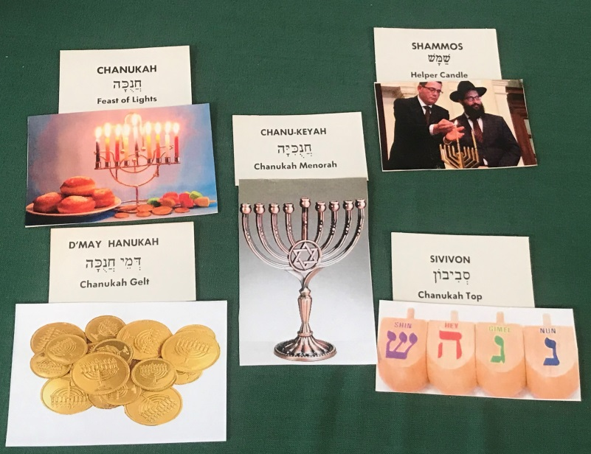
Looking for some place new to vacation, while learning more about Jewish heritage? Jewish Gen is an organization that is helpful in researching our Jewish ancestors, is sponsoring a couple of trips you might be interested in: A Marriage of Different Cultures: The Jews in Cuba (January 29 to February 5, 2019) or The Jews of Iberia: Sephardic Jewry in Portugal (October 23 – November 3, 2019). For more information on these trips contact Jewish Heritage Travel at 845-256-0197 or on their website jhtravel.org.

The North Louisiana Jewish Federation is hosting the Holocaust Essay and Poetry contest in Monroe in May, 2019. Schools will be invited to have their students submit entries, either an essay or a poem, about the impact of the Holocaust on humanity. We are looking for sponsors to cover the costs of this project, including the Amazon gift card prizes for the 1st and 2nd place winners in each category. Sponsors will be recognized in the program. For more information, contact Sandra Blate.
~~~~~~~~~~~~~~~~~~~~~~~~~~~~~~~~~~~~~~~~~~~~~~~~~~~~~~~~~~~~~

~~~~~~~~~~~~~~~~~~~~~~~~~~~~~~~~~~~~~~~~~~~~~~~~~~~~~~~~~~~~~

REPRINTED FROM LAST YEAR’S NEWSLETTER BY REQUEST

Kaplan-Lester compares each night to a room of a house and suggests themes for each night with a meditation before lighting each candle:
First Night – Dedicated to Darkness (The Cellar): Before you light the first candle, stand quietly in the darkness and sense the sanctuary that is yourself. Standing in the cellar of yourself, with an unlit candle in your hand, in the darkness, you discover a deeper self than light lets in. This night is dedicated to the unknown.
Meditation: I dedicate this night to every question I have quested after, to every confusion that has humbled me, to every challenge I have mastered, to the thrill of secrecy. As this candle casts a shadow, myself in dark outline, I integrate and dedicate the darkness with the light. The first night is for the dark cellar of winter, that which illumines a deeper insight.
Second Night – Dedicated to Ascension (The Stairway): As you light the second candle imagine a stairway rising before you. Each step is a worthy act, a good word you have spoken, a good deed you have done. Each step leads to the next. Dedicate yourself to single steps in an upward direction; go out of your way to do one new kindness each day of Chanukah.
Meditation: This night is dedicated to increase, to the second step of every path. This is why we light an additional candle each night. For holiness, like light, should always advance, like an ascending staircase. Just as each good act gives forth another, one spark springs forth to a second wick while a string of candles awaits. I stand at the staircase, ready to rise, ready to explore. From the darkness, I move upward with the second step.
Third Night – Dedicated to Decisions (The Hallway): Imagine yourself in a hallway, an endless corridor. Before you are many doors. Each offers opportunity, each offers an unknown path…letting you choose, challenging you to act. The hallway is the narrowness that leads to expansion. The hallway is the tension before any great act.
Meditation: This night is dedicated to direction, to making decisions in the dark, to taking the leap of faith that leads to miracles. From the narrowness of Greek domination, the Maccabees chose the doorway to freedom. They did not remain confined. They lunged fearlessly for the doorway of independence. Contemplate the path to your future and light three candles as your guide.
Fourth Night – Dedicated to the Senses (The Dining Room): This is the seat of appetite, brimming with all things delightful to the senses. See yourself seated at a beautifully set table. How full is your plate? How great is your need? As your body eats, how nourished is your spirit? Do you take only what you need or do you take too much?
Meditation: This night is dedicated to delicate balances where our desires come to dine offering pleasure in each embellishment, fuel for the fire of life though oil anoints and nourishes, over pour and it will put out the light. Everything needs balance.
Fifth Night – Dedicated to Defiance (The Courtyard): See yourself standing in a courtyard stained with suffering. Think of all those who gave their lives and fought for what they believed in. The fifth night finds our strength tested and we must stand strong against external forces.
Meditation: This is a night dedicated to persistence, a night not to be afraid to sacrifice. It is a night of knowing one’s identity, of being grounded in an inner courtyard of calm and courage, regardless of the chaos of the world outside. Try to block out the noise and find a bit of peace deep inside yourself.
Sixth Night – Dedicated to Rebirth (The Bedroom): Find yourself beneath a canopy, recall the seasons of your days. Are you satisfied with the path you have walked? The bedroom provides a cocoon, a womb, a tomb, a room of rejuvenation. We lay our souls to rest here, our breath slows, the world recedes. We experience the end of all, only to dream, and be reborn, burdenless in the morning. In our lifetime, we witness many lives, personalities developed and discarded, many births and many deaths.
Meditation: This night is dedicated to rebirth. Just as the Temple in Jerusalem was lost and won and lost again, so too are we forever falling, and redefining, losing and re-finding, a new beginning born with every end. Each night when we fall asleep, we are reborn each morning. The six flames we light tonight lift like a phoenix, reviving life in a circle. Though history be a looping spiral, redemption lies at the end of the line.
Seventh Night – Dedicated to the Miracle (The Light in the Window): As you light your menorah in front of the open window, look outside and see the face before you. It is your reflection, your own eyes. What do you see in the window’s mirror? What miracles are there for you to behold?
Meditation: The seventh night is dedicated to the window of the world. This is where the strength and purpose that you have nurtured within are celebrated in the sight of others. This is the show of lights that sparkles forth from self. It is the
commandment of Chanukah to do pirsum hanes—“to advertise the miracle,” the miracle that was wrought in history, that is wrought within us. May our eyes behold the miracles shining forth from each passing soul. And as we gaze into their windows may our own miracle be beheld as we behold.
Eighth Night – Dedicated to Transcendence (The Rooftop): Imagine yourself standing on a roof watching the night fall. As the blue of the sky deepens to black, you see a single star. Then you see more and more stars shining like the lights of the menorah. Dazzled by stars beyond count, you face the infinity of space. Feeling this limitlessness, you are reminded of the infinity of your own soul. The menorah is fully lit. Complete. We are reminded of God’s light that has no end.
Meditation: The eighth and final night is dedicated to transcendence. Just as the seven days of the week represent linear time and the completion of the physical, the number eight is an elegant leap beyond the linear, and beyond physicality. Eight represents transcendence. Just as miracles themselves transcend the limits of the physical realm, so does the number eight beckon us to transcendence.
Although the eighth night represents the end of this holiday of Chanukah, it also hints at the limitless holiness of every day. Yes, there were eight nights of miraculous oil, but beyond that, every day holds its own special miracles. When we are in touch with the infinite light of our own souls, then we are in touch with the infinitude of God. This final night of Chanukah celebrates our transcendent spirits and God’s promise of always being in our lives.
~~~~~~~~~~~~~~~~~~~~~~~~~~~~~~~~~~~~~~~~~~~~~~~~~~~~~~~~~~~~~

