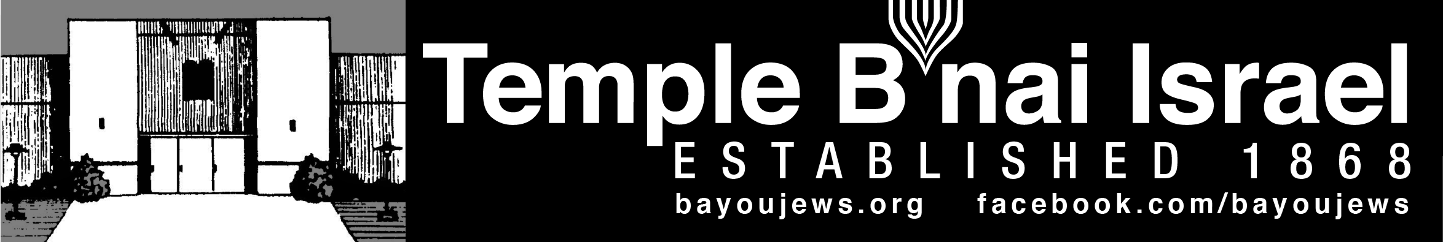
October 2018
Tishrei 22, 5779 – Heshvan 22, 5779
______________________________________________________________________________
______________________________________________________________________________
RABBI JUDY’S MESSAGE
I would like to thank everyone who helped make the High Holy Days this year so spiritual and meaningful. It was so nice to look out on Rosh Hashanah evening and see an almost full sanctuary! That is a beautiful sight for a Rabbi!
Thanks to Betsy Laudenheimer and the Sisterhood for the lovely 150th champagne and cake reception we had after the Erev Rosh Hashanah service and for the Break the Fast after Yom Kippur. Also to Alan and GayNell Barth for the additional refreshments during Rosh Hashanah and the challah. Thanks to the Men’s Club for making sure the social hall had enough lights and setting things up for the oneg. Thanks to everyone who sat on the pulpit and helped with various parts of the services. Thanks to everyone who read parts of the services. And, many, many thanks to Shirley who holds everything together and worked so hard to make these holy days special for all of us. We certainly do appreciate you and your dedication to the Temple.
I am sorry I will miss being with you for the celebrations of Sukkot and Simchat Torah this year, but I will be with you on the weekend of October 19-20. On that Shabbat, we will read the Torah portion for Lech Lecha Friday evening. We will continue our in-depth Torah study on Exodus Chapter 19 and we will learn more about our most important Jewish holiday - Shabbat at our Tot Shabbat.
I hope you will all pick up a brochure for our Kallah and consider joining us for this special retreat weekend in early April, 2019. We would also welcome your help in planning the Kallah. We need people to help plan activities for fun, activities for study, special activities for families who attend, a tikkun olam project and more. If you are interested in helping, please let Susan Marx know.
See you on the 19th!, Rabbi Judy
~~~~~~~~~~~~~~~~~~~~~~~~~~~~~~~~~~~~~~~~~~~~~~~~~~~~~~~~~~~~~

MESSAGE FROM THE PRESIDENT

I want to thank Rabbi Judy and the choir for their beautiful High Holy Days services. The services were very inspiring. I also want to thank Shirley for coordinating the various events that took place during the High Holy Days.

Please support the Men’s Club Kosher-Style Hot Dog Sale on November 6th from 10 am to 2 pm so we can continue to fund improvements at the Temple and other activities.

Alan Barth, President

~~~~~~~~~~~~~~~~~~~~~~~~~~~~~~~~~~~~~~~~~~~~~~~~~~~~~~~~~~~~~

SERVICE SCHEDULE

October 5th Kash Schriefer
October 12th Bob Eisenstadt
October 19th Rabbi Judy
October 26th Alan Barth

Lay leaders are subject to change.

~~~~~~~~~~~~~~~~~~~~~~~~~~~~~~~~~~~~~~~~~~~~~~~~~~~~~~~~~~~~~

KALLAH UPDATE

Rabbi Judy and I are working on the Kallah for April 5-7, 2019 at the Wesley Center in Woodworth, LA. The brochures with the registration form are available at the Temple. We are looking forward to our second Kallah and hope each of you will participate. Please call me with any questions or suggestions.

Susan Marx
~~~~~~~~~~~~~~~~~~~~~~~~~~~~~~~~~~~~~~~~~~~~~~~~~~~~~~~~~~~~~

~~~~~~~~~~~~~~~~~~~~~~~~~~~~~~~~~~~~~~~~~~~~~~~~~~~~~~~~~~~~~

MEN’S CLUB

The Kosher-style Hot Dog Sale is November 6th from 10 am to 2 pm, as part of the 150th Anniversary of the Temple. All Temple members are asked to support this event by purchasing and selling tickets. The tickets are $5. You will get a kosher-style hot dog, chips and a soft drink or water. Orders of 20 or more can be delivered. Tickets are now available at the Temple. They can be purchased and/or picked up to sell during office hours or at Friday night services.

The next meeting is Sunday October 7 at 10 am at the Temple.

If you have not yet paid your Men’s Club dues of $35 for 2018-2019, please send them to the Temple. Make your check payable to Temple B’nai Israel-Men’s Club.

Alan Barth, President

~~~~~~~~~~~~~~~~~~~~~~~~~~~~~~~~~~~~~~~~~~~~~~~~~~~~~~~~~~~~

SISTERHOOD NEWS:

“Treat” yourself to our Halloween Luncheon on Tuesday, October 2nd at 11:30 a.m. at Bayou DeSiard Country Club. Please email me or call me at 325-8358 before noon on Thursday, September 27 to make your reservation. If you are not a member of Bayou DeSiard Country Club, you will need to pay by credit card. Cash and checks are not accepted.

Please send your 2018-2019 dues of $35 to:
Pam Rosenberg
3305 Lake DeSiard Drive
Monroe, LA 71201

Betsy Laudenheimer
Sisterhood President

~~~~~~~~~~~~~~~~~~~~~~~~~~~~~~~~~~~~~~~~~~~~~~~~~~~~~~~~~~~~

~~~~~~~~~~~~~~~~~~~~~~~~~~~~~~~~~~~~~~~~~~~~~~~~~~~~~~~~~~~

YAHRZEIT

OCTOBER 5TH

Bella Ehrlick Annette Masur 2-4
Charles Snyder 2-2 Hilda Zavelo Erna Cahn 6-3

OCTOBER 10TH

James Bodan Bertha Levy Kahn
Babette Doernberg Dorothy Hirsch
Max Lerner 3-3 Betty Jane Masur 1-3
Nellie Hirsch Leroy Stern
Bertha I. Scherck 3-17 Minna Harris Smith
Bessie Fishman Gussie Fogel
Bessie Marx Henry Scherck 3-16
Sally Tumaroff

OCTOBER 19TH

Louis I. Lowentritt Albert Marx
Dora B. Haas Gabriel Levine
Leo Zipkes 1-18 Rose D. Pickens
Louis L. Lowentritt, Sr. 4-11 Robert Schendle
Abraham (Pat) Cohen 4-15 Charles Dorn
Eileen Rubin Hanna Seligman 3-5

OCTOBER 26TH

Rhoda Dubin Helena Gill 2-8
Mark Rubin Beatrice Joy Gorn
Ernest M. Strauss Jules Dante
Clifford Strauss William M. Smith
S. K. Bernheim Sophie Laudenheimer 5-13
Rose Marx Haas 2-19

Yahrzeit Continued

OCTOBER 31ST

Morris Mintz Mildred May
Belle Blotner Charles Blotner
Anna Snyder

The numbers following a name is the location of their plaque on the Memorial Board in the Foyer. The first number represents the column. The second number represents the position in the column. The lights on both sides of the plaque are light during the week of their Yahrzeit. If you would like to have your loved one remembered with a bronze plaque on the memorial board, order forms are available at the Temple.

~~~~~~~~~~~~~~~~~~~~~~~~~~~~~~~~~~~~~~~~~~~~~~~~~~~~~~~~~~~~~

RITUAL AND WORSHIP
The High Holy Days were wonderful this year. There are so many people to thank including the many readers and people that sat on the pulpit. Rabbi Judy was awesome as always and her preparation and dedication prepared us for a true reflection of ourselves. The choir was great and the music makes the services so much more meaningful. The sisterhood, as well as Alan and Bill, had a fabulous arrangement and selection of food for our Oneg and Break the Fast. Alan, thank you for trying to cool us off as soon as possible!! A most sincere thanks has to go to Shirley for all her preparation and attention to details to make the High Holy Days special, from climbing on ladders to assuring everything was ready.
I would say for our 150 years in Monroe, we have come a long way AND remembered why we are here. We plan to have an active year in celebrating this milestone. Thank everyone that was a part of the High Holy Days.
We will have a guest Rabbi from the ISJL on the 28th of September and he has a full weekend planned. If his resume is any indication we can learn a lot. Please join us for his visit.

Gay Nell Barth, Chair
~~~~~~~~~~~~~~~~~~~~~~~~~~~~~~~~~~~~~~~~~~~~~~~~~~~~~~~~~~~

~~~~~~~~~~~~~~~~~~~~~~~~~~~~~~~~~~~~~~~~~~~~~~~~~~~~~~~~~~~~~CONGRATULATIONS

HAPPY ANNIVERSARY

Charles and Janet Masur October 12th 60 years
Louise and Wesley Moore October 14th 1 year

HAPPY BIRTHDAY

Brylee Laudenheimer (6 years) – October 3rd Janet Masur – October 8th
Jacob Palmer (4 years) – October 9th Joseph Hakim – October 13th
Ron Blate – October 17th Alice Baize – October 20th

~~~~~~~~~~~~~~~~~~~~~~~~~~~~~~~~~~~~~~~~~~~~~~~~~~~~~~~~~~~~~

DONATIONS

GENERAL FUND

A Speedy Recovery for Gay Nell Barth
Sylvia Masur Thompson
High Holy Days
John Gilcrease Merrijane Yerger
Edwin Caplan Dominic Agbasi
Nancy Kings and Hannah Harris Joe and Cynthia Kern
Curtis Garth Alice Hilderbrand
JJ Dixon Mr. and Mrs. Lavalle Salomon

~~~~~~~~~~~~~~~~~~~~~~~~~~~~~~~~~~~~~~~~~~~~~~~~~~~~~~~~~~~~~

BRONZE PLAQUES AVAILABLE FOR SALE

There is space available for bronze plaques on the Yahrzeit Board in the front foyer. The plaques include the name of your loved one and their Yahrzeit date in both the Gregorian date and the Jewish date. The lights on both sides of their plaque are turned on the week of the Yahrzeit. This is a wonderful way to remember your loved ones. The cost of each plaque is $250.00. Contact the office for more information and to place your order.

~~~~~~~~~~~~~~~~~~~~~~~~~~~~~~~~~~~~~~~~~~~~~~~~~~~~~~~~~~~~
~~~~~~~~~~~~~~~~~~~~~~~~~~~~~~~~~~~~~~~~~~~~~~~~~~~~~~~~~~~~~

MUSEUM/ARCHIVES NEWS
Wow! Moving, designing, and hanging the new museum exhibits continue to be an exciting and challenging experience. I could not have done it alone. I would like to thank Leniese Lassiter of Artistic Frames for donating her time to consult on this project; Josh Ockman and Caitlin Struth for their diligent work redesigning the exhibits in both museum rooms; Chris Kelley for his wonderful restoration work; and Rabbi Judy and Merrijane Yerger for the consultation, suggestions, and all the other hard work they put in to making the museum enjoyable and informative.
There is 174 years of continuous Monroe Jewish history on display. Currently there is also an art display in the Masur Social Hall. Come enjoy and bring your friends to tour our facility. You can tour on your own or I would be happy to give a guided tour with advanced notice.
The St. Paul’s United Methodist Church confirmation class, along with their mentors and other congregation members, enjoyed a tour of the museum and Temple before attending Shabbat services on September 21st. Mazel Tov to Mike Rhymes, who conducted an outstanding explanatory service. After the service, we heard my positive comments regarding the service. Thank you to Alan and Gay Nell Barth for providing the challah.
The museum directors of Ouachita Parish will conduct their October 18th meeting at 12 noon at the Temple. They are responsible for many of the cultural events throughout the parish. The directors are anxious to see our museum and I am sure I can pick up some good suggestions to continue to improve the exhibits. Any congregant is welcome to attend. The museum/archives is responsible for providing a meal for this group. If you would like to come, the cost for lunch is $10 and you need to make a reservation. I would appreciate any assistance you can provide in hosting this event. If you are asked to help, please say yes.
If you are looking for a good read, in our library we have the book, Giants. It gives you a glimpse into the television industry. The book is written by Monroe native, Jack Ansel, Jr. He worked at KNOE before moving to New York to work for ABC.
Sandra Blate
~~~~~~~~~~~~~~~~~~~~~~~~~~~~~~~~~~~~~~~~~~~~~~~~~~~~~~~~~~~~~New Calendars and Directories are available at the Temple.
~~~~~~~~~~~~~~~~~~~~~~~~~~~~~~~~~~~~~~~~~~~~~~~~~~~~~~~~~~~~

Donate to the Temple - AmazonSmile
If you shop on Amazon, you can help the Temple earn a little extra money and it costs you nothing. Amazon has a foundation that donates money to charities of the buyer’s choice. You have all the same items and prices as the general site, but the Amazon will donate to the charity of your choice when you make a purchase. The donation is NOT added to the cost of your purchase. The donation is made entirely from Amazon’s Foundation.
To make the donation, you must login at smile.amazon.com (not the general Amazon site). You use the same login and password you have been using for your regular account. Before you make any purchases on AmazonSmile, you will have to choose your charity. The Temple is listed as Bnai Israel Congregation, Monroe LA (No apostrophe in Bnai).
~~~~~~~~~~~~~~~~~~~~~~~~~~~~~~~~~~~~~~~~~~~~~~~~~~~~~~~~~~~~~

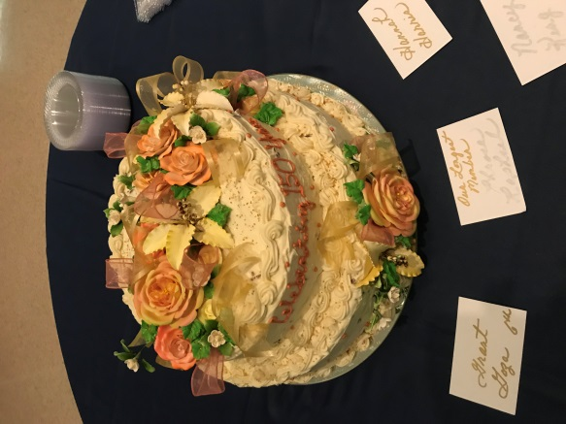
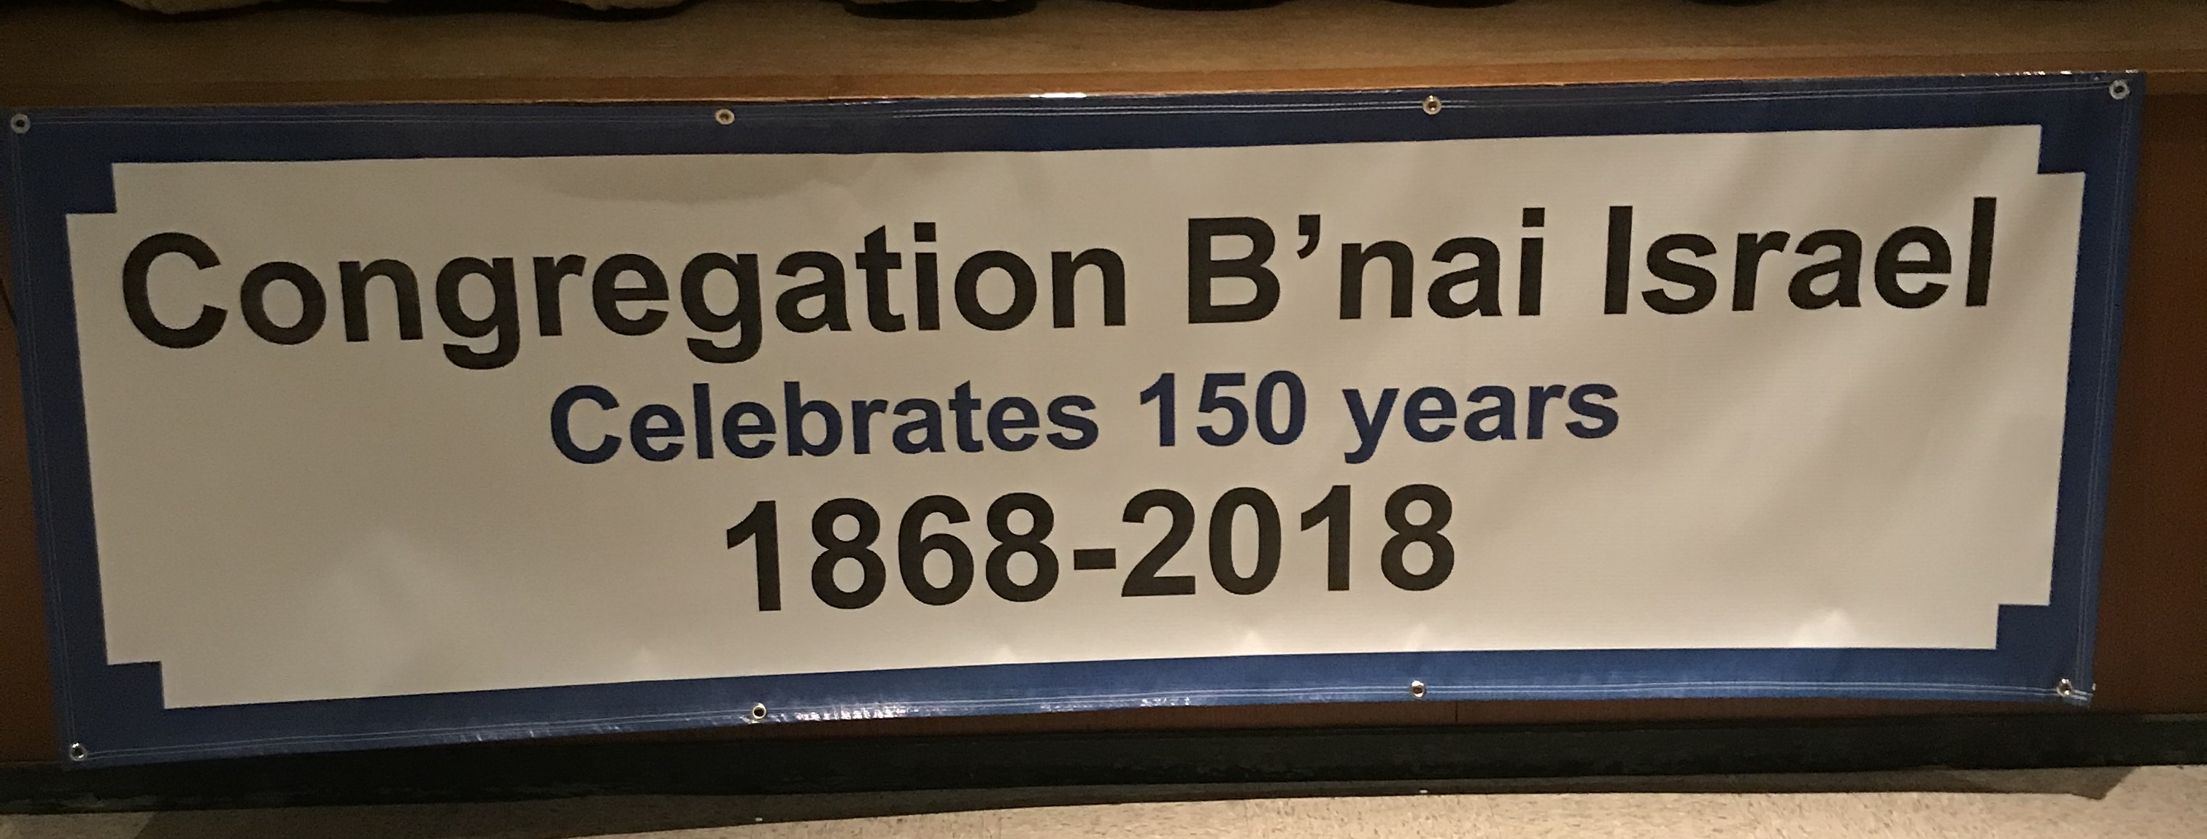

Celebrating 150 Years

