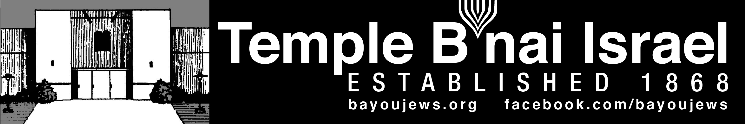
January 2018
Tevet 14, 5778 – Shevat 15, 5778
______________________________________________________________________________
______________________________________________________________________________

Message From Rabbi Judy
I hope everyone had a relaxing holiday season and now a new secular year is upon us. In this New Year, our congregation will celebrate its 150th anniversary. It is amazing to think that there has been an active and vibrant Jewish community in Northeastern Louisiana for this long. What a long history we have. I look forward to learning more about it during this special year of celebration in our community.
On the weekend of January 26-28, 2018, our congregation will host its first Kallah – a gathering to celebrate all that Shabbat has to offer at a restful place away from the Temple. As you know, we were one of 5 congregations this past year who were chosen by The Kallah Project to participate. This first retreat will be held at the Wesley Center in Woodworth, LA and will include Shabbat worship; lots of music with guest song leader, Nick May from Baton Rouge; educational offerings; fun activities such as zip lining, Mah Jong, nature walks, a labyrinth, and more; a Havdalah service and bonfire with s’mores on Saturday evening and a tikkun olam project that will be brought back to the community. We have almost 50 people who have signed up to be there. If you would like to join us, please contact Susan Marx or Shirley in the Temple office. If you need scholarship funds to help you attend, please let me know. We are especially grateful to Rabbi Barb Moskow who has led us every step of the way with planning for this Kallah. Packets will be sent out soon to those who have registered with more information. Hope to see many of you there!
Right after the Kallah, I will be leaving to travel to India on a Jewish cultural heritage tour. This is a trip I have been planning for about 3 years – ever since I first visited India in 2015. I will be traveling all over India and celebrating Shabbat with two different Jewish families. When I return in March, I hope to be able to share highlights from this trip with you.
May this New Year be one of health, happiness and kindness for us all.
Rabbi Judy
~~~~~~~~~~~~~~~~~~~~~~~~~~~~~~~~~~~~~~~~~~~~~~~~~~~~~~~~~~~~~
~~~~~~~~~~~~~~~~~~~~~~~~~~~~~~~~~~~~~~~~~~~~~~~~~~~~~~~~~~~~~

YAHRZEIT

JANUARY 5TH

Sanford Halperin Esther B. Masur
Max Strauss Wilma Zavelo Marx
Hattie Lowentritt Bessye L. Stern

JANAURY 12TH

Otto Haas Harriet Kern
Herman Masur Manuel Slipakoff
Abe Froug Sam Smith
Doniel Weil Lillian Heninger
Philip Wilenzick Louis Flemin
Maurice Roby Dora Israel
Dula Mae Roby Sol Arthur Stern
Carl Goettinger Yetta Leibowitz
Ralph Marks

JANUARY 19TH

Leopold Hirsch Maude Selig
Joan Halperin Stanley Shlosman
David Masur Joe Doernberg
Rachel Rosenberg Marvin Carlie
Louise Hakim Clem Heninger
Stella Heninger

JANUARY 26TH

Moise King Dr. Fred Marx
Louis Masur David Masur
Morris B. Rosen Sol Rosenberg
Sam Rubin, Sr. Jakob Strauss
Dr. Samuel Lewis Virginia Marx
Sam Zavelo Alan Blumenthal
Jan Fishman Leonard Lemle
Louis Weinberg Carol Marx
Yahrzeit continued
JANUARY 31ST

Ida Scherck Bogen Lenore Schwelling
Dora Heiman Edgar Masur
Abraham Blumenthal Minnie Kristal Levine

~~~~~~~~~~~~~~~~~~~~~~~~~~~~~~~~~~~~~~~~~~~~~~~~~~~~~~~~~~~~~

CONGRATULATIONS

HAPPY BIRTHDAY

Danielle Roa (17 years) – January 10th Brianna Roa – January 11th
Cecile Smith – January 20th Phyllis Marcus – January 22nd
Carly Laudenheimer (2 years) – January 22nd Tanya Speyrer- January 22nd
Michal Hakim – January 26th Ron Israel – January 27th

Annie Richardson became a grandmother for the second time. Haas Marie Burt was born December 12, 2017. Her big sister is Blake Lockwood. Congratulations to the whole family.

Kallah! Kallah! Kallah!
It is almost here! The much anticipated Kallah is the end of this month and we are working hard to make it a wonderful experience for all. You can still sign up--it's not too late and we would love to have you! You can join the 46 of us who are attending so far and have a meaningful and fun weekend.
The activities will be extraordinary and never a dull moment, unless you choose not to participate! Please consider joining us!
Rabbi Barb Moskow from Chicago will be here in Monroe on Tuesday, January 9th all day. We will meet as a committee with her that night at 7 p.m. So, if you have any questions for her or for me, please feel free to call me any time. Shirley, who has done a wonderful job for us, will also be available for questions.
Thanks to all of you who are working on this Kallah and to those who have come forth to volunteer food and supplies. I look forward to hearing from you and seeing you at the Kallah.
Susan ~~~~~~~~~~~~~~~~~~~~~~~~~~~~~~~~~~~~~~~~~~~~~~~~~~~~~~~~~~~~~
~~~~~~~~~~~~~~~~~~~~~~~~~~~~~~~~~~~~~~~~~~~~~~~~~~~~~~~~~~~~~

MEN’S CLUB

Next Men’s Club Meeting is January 14, 2018 at 10:00 am.

Thank you to all the men who came out to cook latkes for the Hanukkah Party and to all members who came and brought food. It made for an enjoyable time.

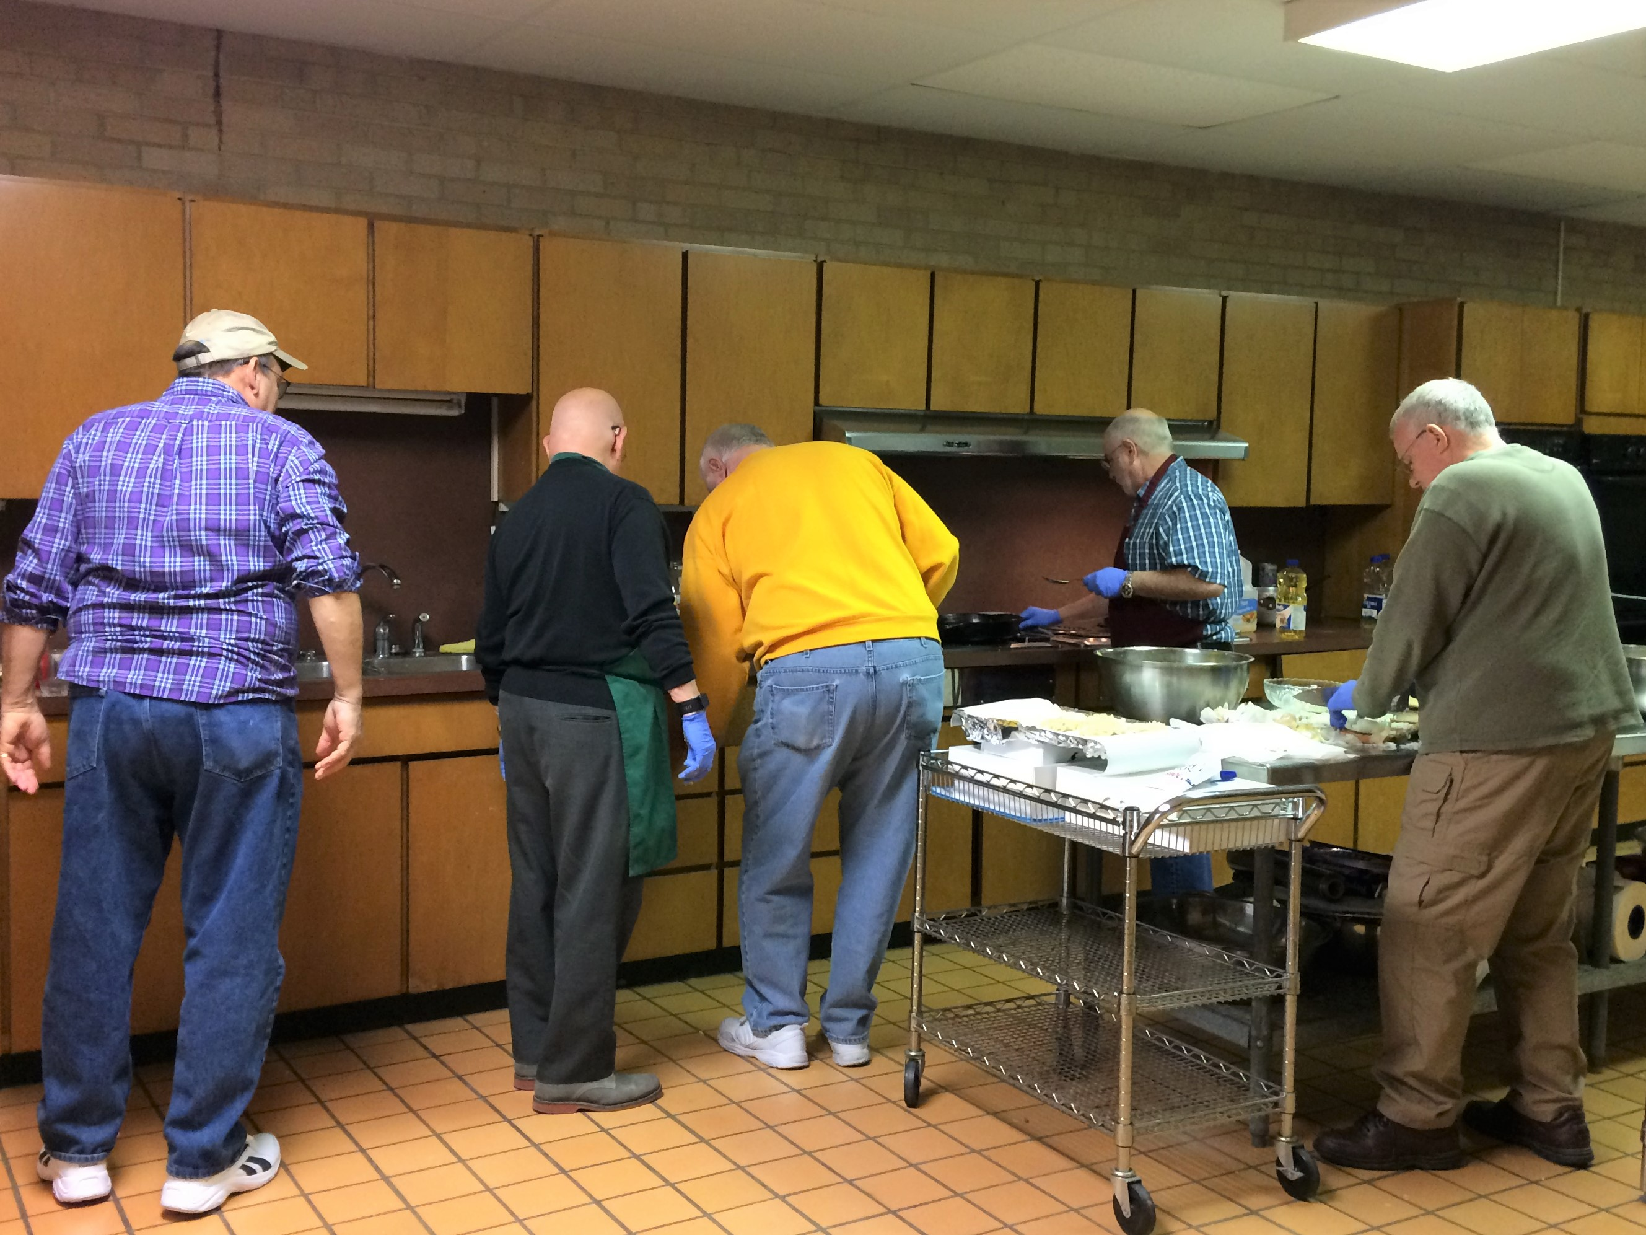
Men’s Club making latkes. - Alan Barth, Ron Blate, Bill Levinson, Joseph Hakim, John Allen

If you have not yet paid your dues, please do so as soon as possible. They can be sent to the Temple, Attn: Men’s Club.

~~~~~~~~~~~~~~~~~~~~~~~~~~~~~~~~~~~~~~~~~~~~~~~~~~~~~~~~~~~~~

~~~~~~~~~~~~~~~~~~~~~~~~~~~~~~~~~~~~~~~~~~~~~~~~~~~~~~~~~~~~~

SERVICE SCHEDULE

JANUARY 5TH TBA
JANUARY 12TH Kash Schriefer
JANUARY 19TH TBA
JANUARY 26TH Bill Levinson, Monroe
Rabbi Judy, Kallah

Lay leaders are subject to change.

~~~~~~~~~~~~~~~~~~~~~~~~~~~~~~~~~~~~~~~~~~~~~~~~~~~~~~~~~~~~~

ARCHIVES NEWS

Mr. Joe Kern, Jimmy Kern’s father, served on the original committee that established the Precious Legacy Archive. One of this many contributions was a paper he wrote on the businesses located in downtown Monroe from the late 1800s to the early 1900s. I have expanded that paper to cover all the Jewish stores, including the last downtown Jewish owned business to close. It is nice to see DeSiard Street is returning to its origins – residential and business.

Modern technology! It is amazing! On December 20th, I was asked to share the store of Chanukah in a live interview at 6:30 am on KZRZ Sunny 98.3. The interview was broadcast on Facebook Live, which instantly streams live to their friends and followers and can interact with viewers in real time. KZRZ got the idea of doing a live video broadcast from Mayim Bialik’s, who plays Amy on The Big Bang Theory, YouTube presentations on Chanukah.

Sandra Blate

~~~~~~~~~~~~~~~~~~~~~~~~~~~~~~~~~~~~~~~~~~~~~~~~~~~~~~~~~~~~~

SISTERHOOD NEWS

Mark your calendars for Tuesday, February 6th for Sisterhood’s Valentine Luncheon at 11:30 a.m. at Genusa’s Restaurant on Park Avenue. Please call or email Betsy Laudenheimer for reservations by Thursday, February 1st.

~~~~~~~~~~~~~~~~~~~~~~~~~~~~~~~~~~~~~~~~~~~~~~~~~~~~~~~~~~~~~
~~~~~~~~~~~~~~~~~~~~~~~~~~~~~~~~~~~~~~~~~~~~~~~~~~~~~~~~~~~~~

Limmud New Orleans Open to All
Every two years, the New Orleans community hosts Limmud, a weekend festival of Big Tent Jewish learning, arts, culture and spirituality. Next year, it will be held on the weekend of March16-18, 2018 at Gates of Prayer in Metairie and the Uptown JCC in New Orleans. This weekend is open to everyone in Louisiana and features wonderful presenters from around the country offering over 90 workshops on a variety of interesting topics. You will also be a part of worship services filled with music and spirit and be treated to an outstanding program Saturday evening.
The cost of Limmud is very affordable – Early bird registration (which ends Jan 31) is only $80 for the whole weekend for an adult….you can bring the whole family too (registration is $45 for those age 18-30 and $15 for children. This rate includes all activities Friday evening, activities all day Saturday including services, study sessions, Havdalah and a Saturday evening program, workshops on Sunday and kosher meals and snacks. There is a special rate for hotels in Metairie or you can ask for home hospitality. They even have some scholarships available if the registration fee is a hardship.
Rabbi Judy will be presenting a family song session on Saturday morning and an educational session on Sunday. This is a terrific opportunity to be with several hundred Jewish people where we can pray together, enjoy great programs and learn from one another. For more information, please visit www.limmudnola.org

~~~~~~~~~~~~~~~~~~~~~~~~~~~~~~~~~~~~~~~~~~~~~~~~~~~~~~~~~~~~

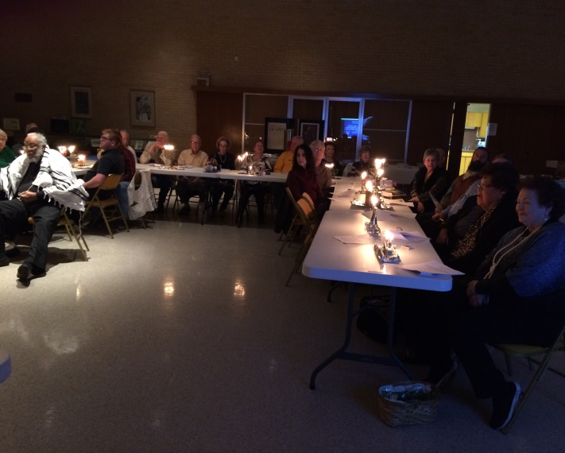
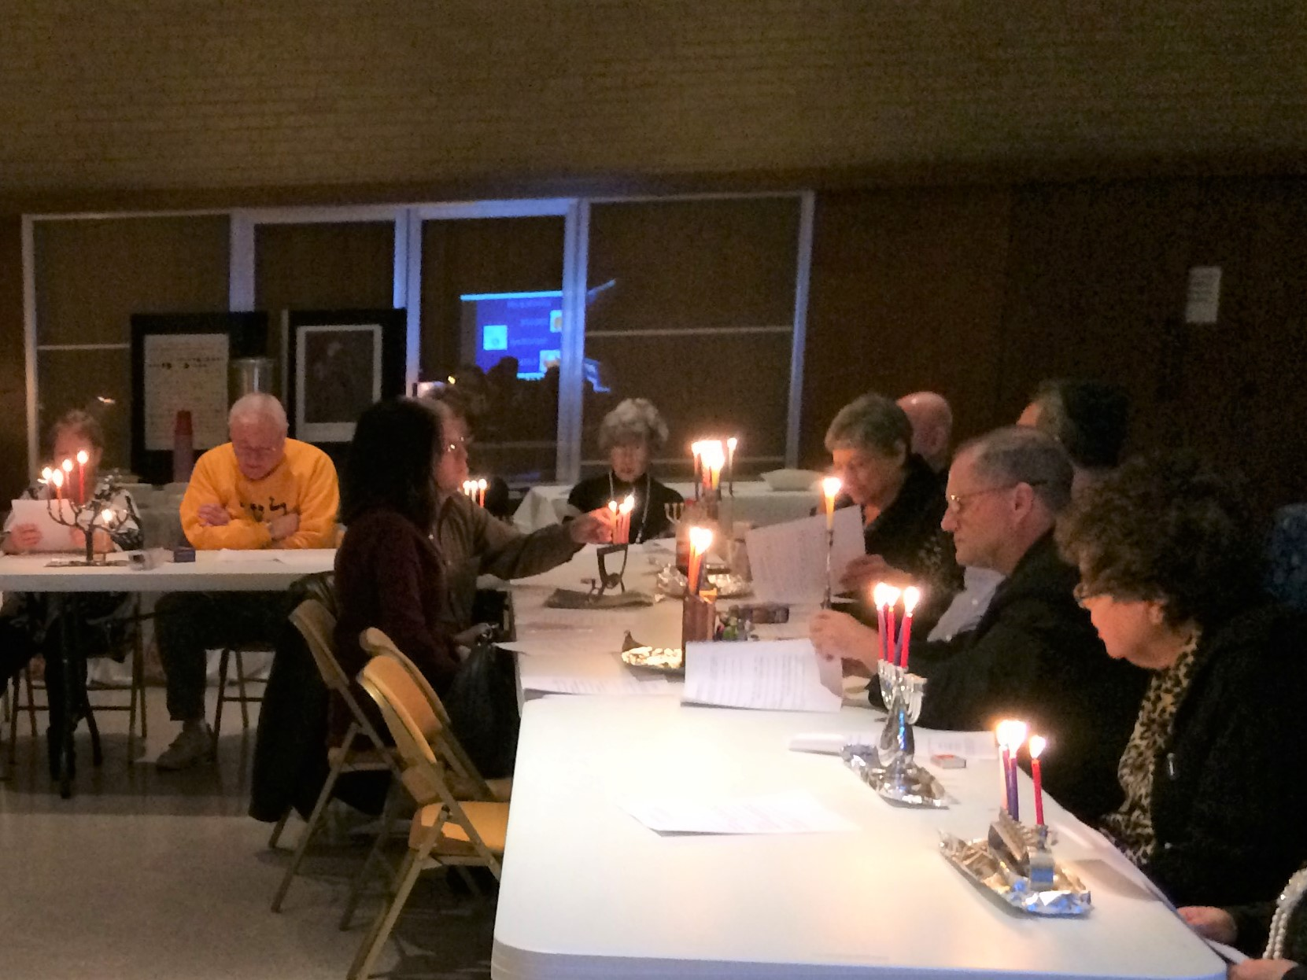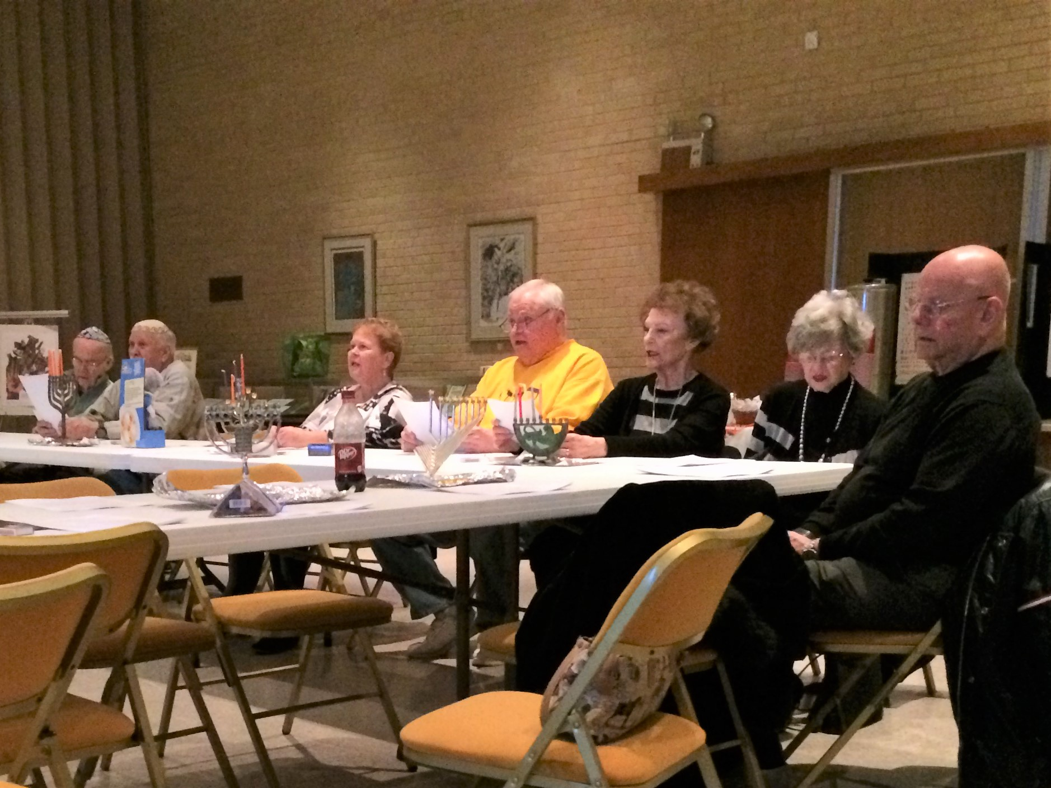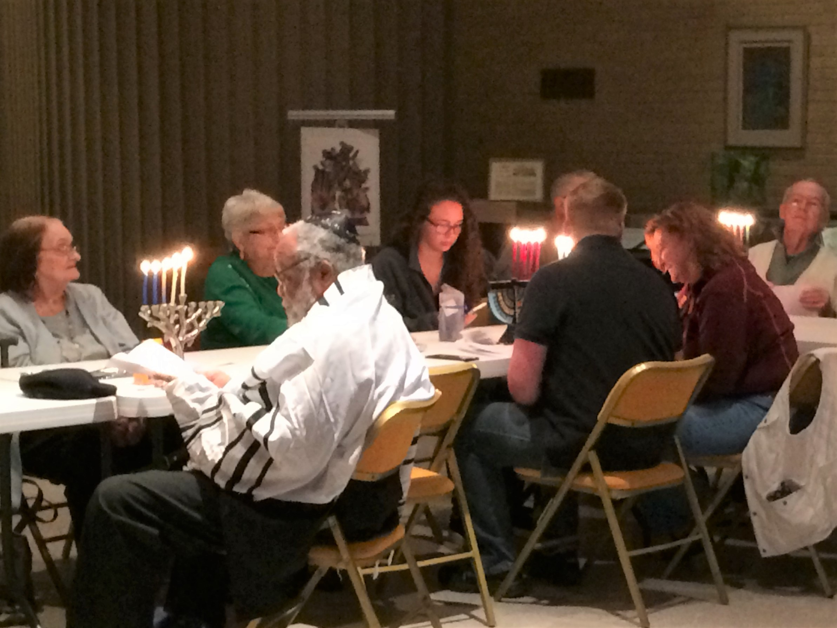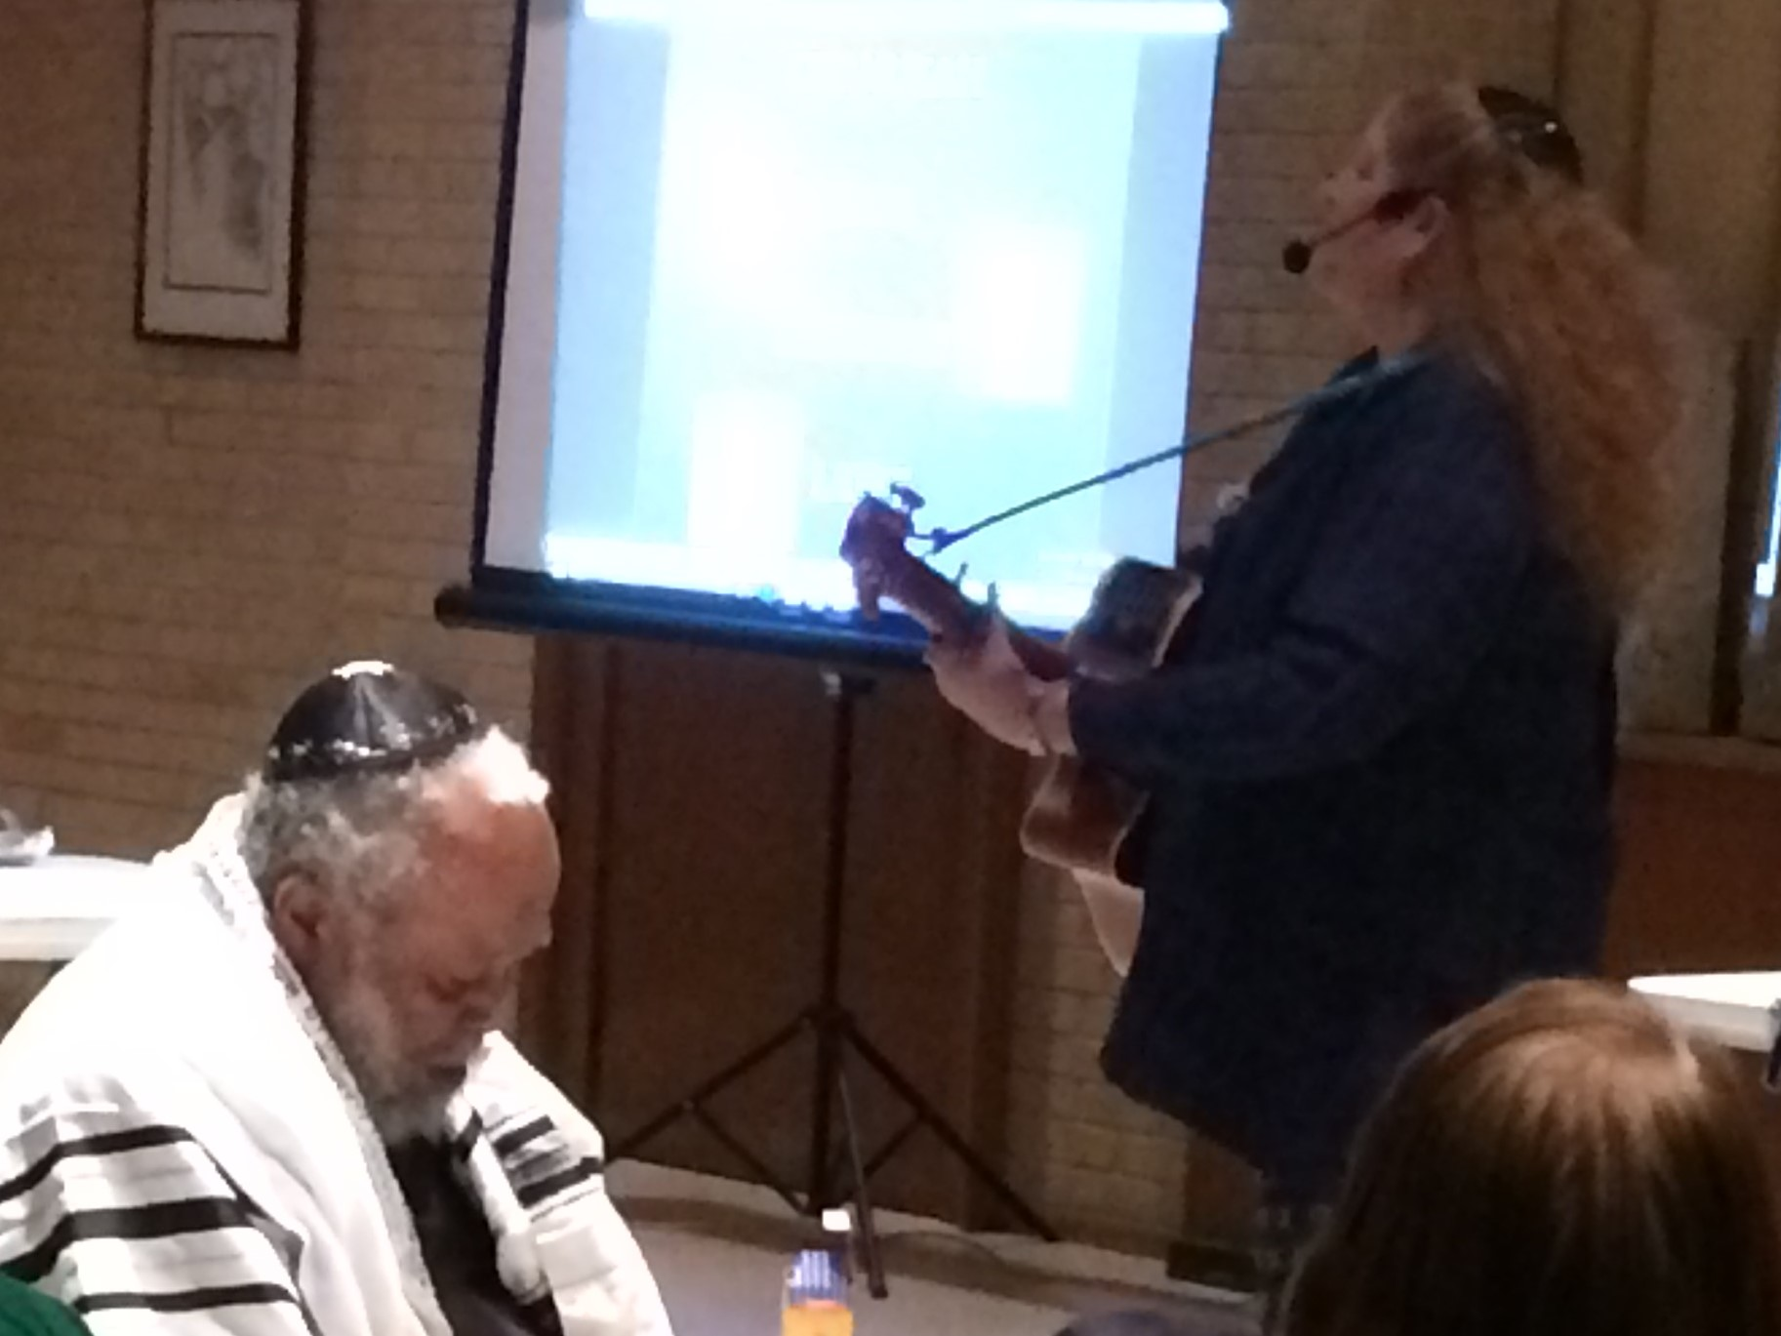
PICTURES FROM THE HANUKKAH PARTY

THE PARTY FOOD
AND
TOT SHABBAT

~~~~~~~~~~~~~~~~~~~~~~~~~~~~~~~~~~~~~~~~~~~~~~~~~~~~~~~~~~~~~~~~~~~~~~
DONATIONS

General Fund
For the Yahrzeit of Carol Super Gold’s Father, Victor Cahn, her uncles, Uncle Oscar Cahn and Uncle Eugene Cahn, and her mother’s first cousin, Greta Kende
Carol Cahn Super Gold and Ron David Gold

Cemetery Fund
In honor of Mel and Nanette Cohen’s 40th Anniversary
Don and Phyllis Marcus
~~~~~~~~~~~~~~~~~~~~~~~~~~~~~~~~~~~~~~~~~~~~~~~~~~~~~~~~~~~~~~~~~~~~~~

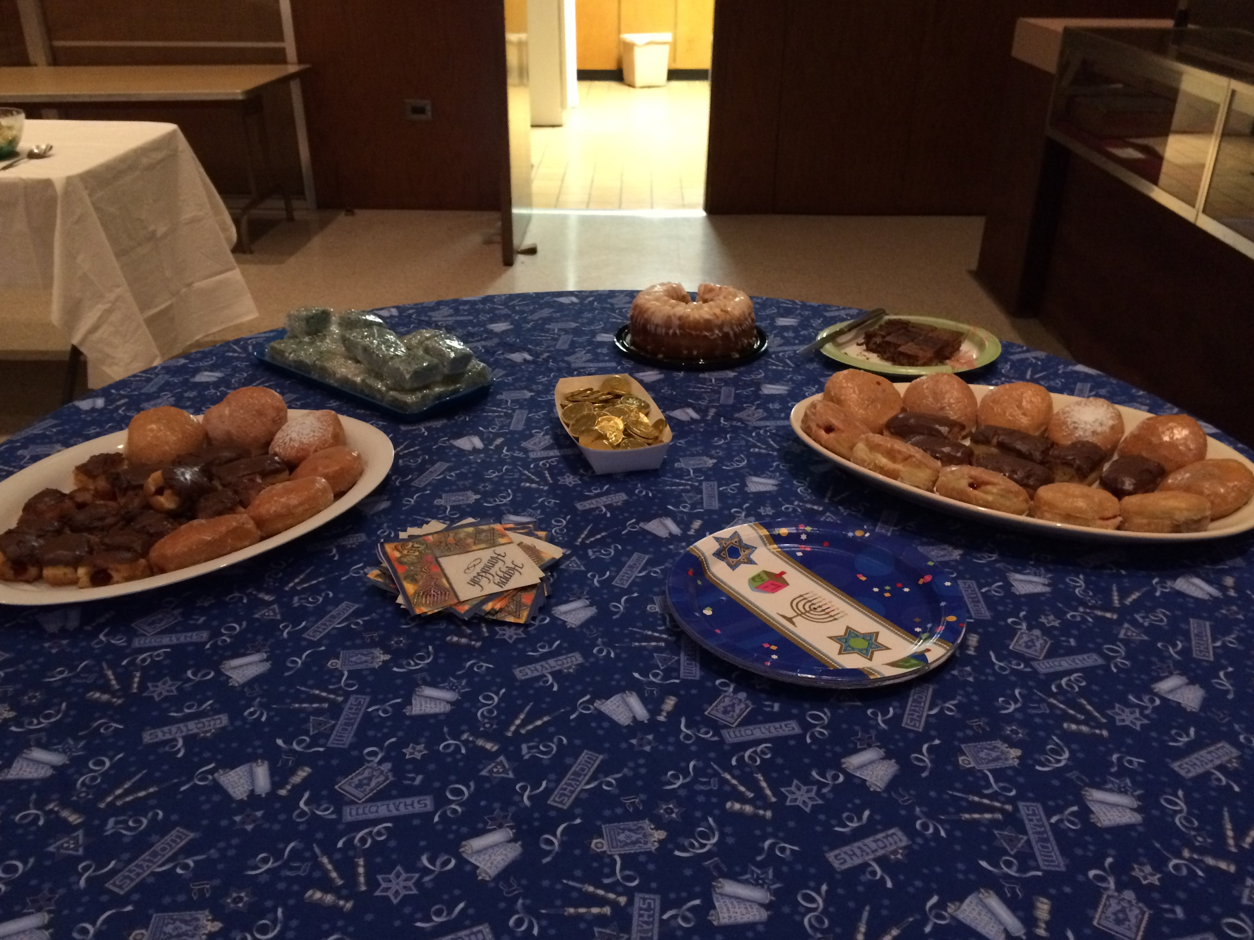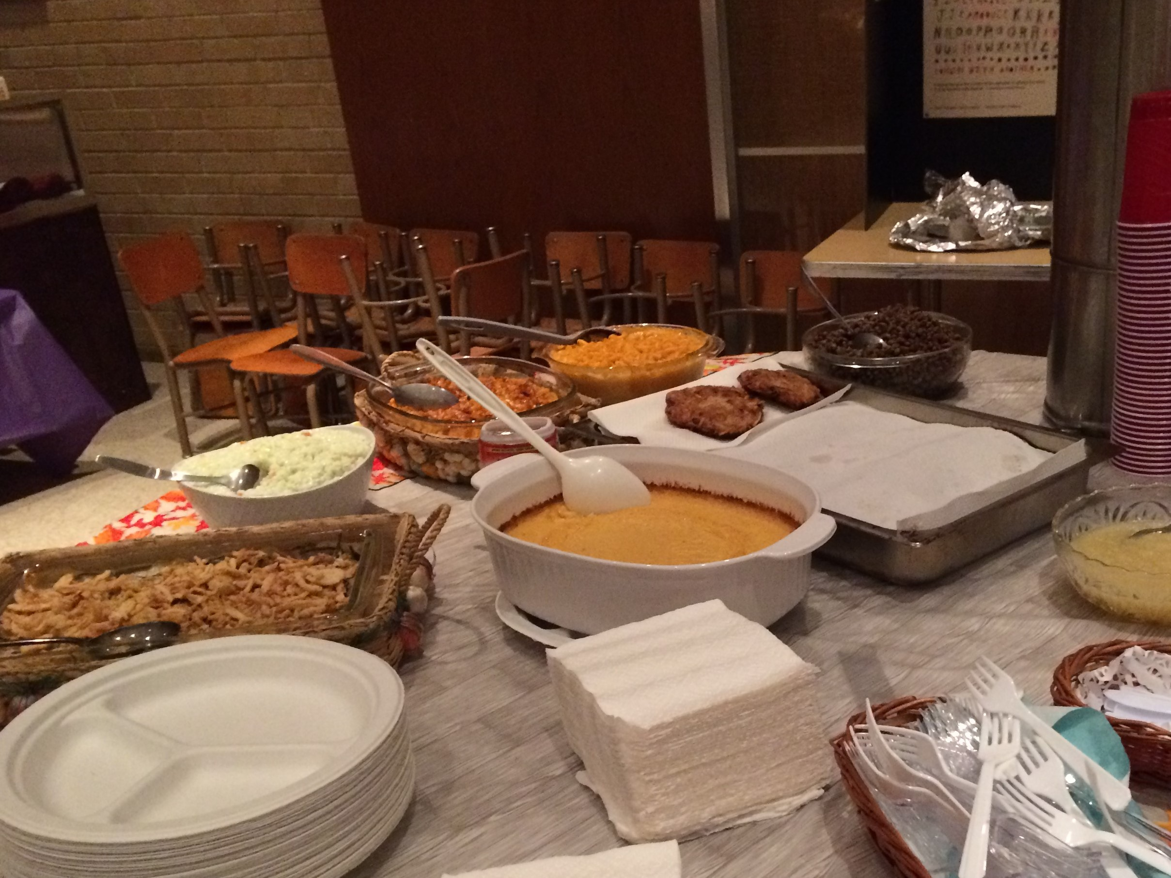
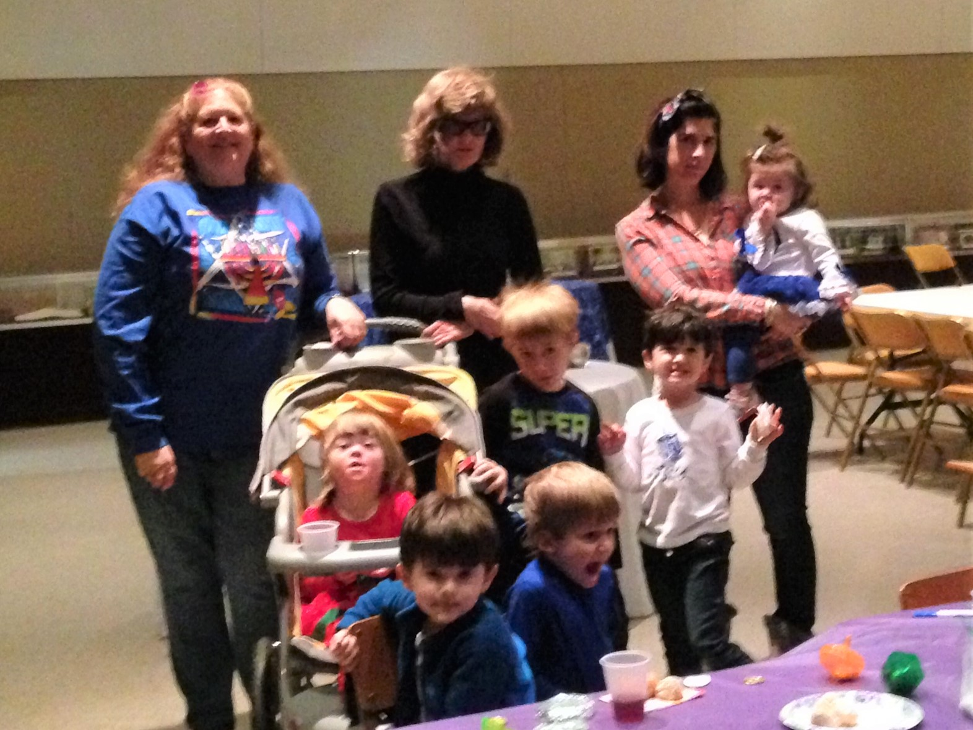

~~~~~~~~~~~~~~~~~~~~~~~~~~~~~~~~~~~~~~~~~~~~~~~~~~~~~~~~~~~~

North Louisiana Jewish Federation
A donation to the North Louisiana Jewish Federation provides:
Money for Israel
Money for campers - Henry S. Jacobs and Kutz
Money to help fight anti-antisemitism
Money for other Jewish agencies
The Goldring Family Foundation provides $1000.00 non-needs based scholarships to all first time Jewish campers in our region. To obtain an application form call Ellen Abrams at (504)524-4559 or contact jewishcamping@jefno.org. Henry S. Jacobs Camp fee is $2,300 - $6,800.00 for a summer session depending on the child's age. Registration for Summer 2018 is going on now.

Send your donations to:
North Louisiana Jewish Federation
245-A Southfield Road
Shreveport, LA 71105

~~~~~~~~~~~~~~~~~~~~~~~~~~~~~~~~~~~~~~~~~~~~~~~~~~~~~~~~~~~~

REQUEST FOR DONATION ITEMS FOR A KALLAH PROJECT

If you travel and stay in hotels, you probably bring home those small sized soaps, lotions, shampoos, conditioners, etc. from the hotel. We would like to ask you to please collect and share these with us so that we can use them for a Tikkun Olam project at the Kallah. Tikkun Olam literally means “repairing the world.” On Sunday morning at the Kallah, we will, as a community, participate in a Tikkun Olam project which will help our neighbors who are in need in Monroe. Just drop the unused samples off to Shirley at the office and she will save them for us to use at the Kallah. We appreciate your help!

~~~~~~~~~~~~~~~~~~~~~~~~~~~~~~~~~~~~~~~~~~~~~~~~~~~~~~~~~~~~

